**EASTERN INTERNATIONAL UNIVERSITY**

**SCHOOL OF COMPUTING AND INFORMATION TECHNOLOGY**

**DEPARTMENT OF SOFTWARE ENGINEERING**



**PROJECT 2 REPORT**

**ANNA COSMETIC WEBSITE**

**Students**

Phan Ngoc Hanh Nhi– 2131209002

Tran Mai Anh – 2231200062

**Supervisor**

Ung Van Giau

**Binh Duong, March 2025**

ABSTRACT

ANNA Cosmetic is an innovative web application designed to transform the online beauty shopping experience by providing a seamless and personalized platform for users. By centralizing product information and customer preferences, the platform simplifies the discovery and purchase of cosmetics while ensuring a user-friendly and enjoyable experience.

For customers, ANNA Cosmetic offers intuitive navigation, detailed product descriptions, personalized recommendations, and secure transactions, making it easy to find products that meet their unique beauty needs. The platform also includes educational resources, empowering users with knowledge about skincare and makeup trends to make informed purchasing decisions.

From a business perspective, ANNA Cosmetic streamlines inventory management, optimizes customer interactions, and provides valuable insights into consumer behavior. With its commitment to innovation and excellence, the platform enhances customer satisfaction while fostering long-term brand loyalty.

With a sleek design and robust functionality, ANNA Cosmetic represents a significant step forward in e-commerce, redefining the way beauty enthusiasts connect with their favorite products and brands. It serves as a comprehensive solution for modern beauty needs, blending technology with the art of self-expression.

ACKNOWLEDGEMENT

We extend our deepest gratitude to our college faculty and project guide, Mr. Ung Van Giau, for his invaluable support and guidance throughout the development of the ANNA Cosmetic website. His profound expertise, insightful feedback, and consistent encouragement have been instrumental in steering our project towards its successful completion.

Additionally, we would like to acknowledge the numerous professionals and developers who have shared their knowledge through online tutorials, forums, and articles. Their contributions have significantly enriched our understanding of web technologies and e-commerce development, empowering us to create a robust and user-friendly platform. This collective wisdom has played a pivotal role in shaping ANNA Cosmetic into a dynamic solution for the modern beauty market.

TABLE OF CONTENTS

**ABSTRACT i**

**ACKNOWLEDGEMENT ii**

**LIST OF FIGURES v**

**LIST OF TABLES vi**

**LIST OF ABBREVIATIONS vii**

**CHAPTER 1. OVERVIEW 1**

1.1. Introduction 1

1.2. Project objectives 1

1.3. Challenges 2

1.4. Report structure 3

**CHAPTER 2. INTRODUCTION TO TECHNOLOGIES 4**

2.1. HTML 4

2.2. CSS 5

2.3. JavaScript 6

2.4. ASP.NET Core 7

2.5. MySQL 8

2.6. GitHub 9

**CHAPTER 3. APPLICATION ANALYSIS, DESIGN AND IMPLEMENTATION 11**

3.1. Requirements 11

3.1.1. User Groups 11

3.1.2. Core Features 11

3.1.3. Use Case Diagram 11

3.1.4. Scope 12

3.2. Use case diagram 12

3.2.1. Admin use case diagram 12

3.2.2. Customer use case diagram 14

3.3. Database 15

3.3.1. ERM diagram 15

3.3.2. Table in database 15

3.4. Introduction to ASP.NET Core 17

3.4.1. Installation 17

3.4.2. ASP.NET Core Project Structure 17

3.4.2.1. Root Directory 17

3.4.2.2. Folders 17

3.4.2.3. Key Files 18

3.4.2.4. Creating and Initializing the Project 18

3.4.2.5. Configuring ASP.NET Core 18

3.4.2.6. Running the Application 19

3.4.2.7. Advanced Configurations 19

3.5. CRUD for Admin 20

3.5.1. Create new category 20

3.5.2. Read category 21

3.5.3. Update category 22

3.5.4. Delete category 24

**CHAPTER 4. EXPERIMENT AND DISCUSSION 26**

4.1. Installation Environment 26

4.2. Results and Discussion 26

4.2.1. Home page for customer 26

4.2.1.1. Interface and Features Implemented 28

4.2.1.2. Overall Evaluation 29

4.2.2. CRUD for admin 29

4.2.2.1. Create Category 30

4.2.2.2. Read 31

4.2.2.3. Update 31

4.2.2.4. Delete 32

4.2.2.5. Additional Features 33

4.2.2.6. Overall Evaluation 33

**CHAPTER 5. CONCLUSION AND FUTURE WORKS 34**

5.1. Conclusion 34

5.1.1. Knowledge Gained 34

5.1.2. Product Outcomes 34

5.1.3. Skills Developed 35

5.1.4. Team Growth 35

5.2. Future works 35

**REFERENCES 37**

LIST OF FIGURES

Figure 1. HTML Logo 4

Figure 2. CSS Logo 5

Figure 3. JavaScript Logo 6

Figure 4. ASP.NET Core Logo 7

Figure 5. MySQL Logo 8

Figure 6. GitHub Logo 9

Figure 7. Admin use case diagram 12

Figure 8. Customer use case diagram 14

Figure 9. ERM diagram 15

Figure 10. Create activity diagram 20

Figure 11. Read activity diagram 21

Figure 12. Edit activity diagram 22

Figure 13. Delete activity diagram 24

Figure 14. Home page 27

Figure 15. Create category interface 30

Figure 16. Read category interface 30

Figure 17. Update category interface 31

Figure 18. Delete category interface 32

Figure 19. Delete category successfully interface 32

LIST OF TABLES

Table 1. Table Customer 15

Table 2. Table Product 16

Table 3. Table Order 16

Table 4. Table OrderDetail 16

Table 5. Table Admin 17

LIST OF ABBREVIATIONS

|  |  |  |
| --- | --- | --- |
| **No.** | **Term** | **Meaning** |
| 1 | HTML | HyperText Markup Language |
| 2 | CSS | Cascading Style Sheets |
| 3 | SQL | Structured Query Language |
| 4 | API | Application Programming Interface |
| 5 | HTTPS | Hypertext Transfer Protocol Secure |
| 6 | ASP | Active Server Pages |
| 7 | UI | User Interface |
| 8 | CRUD | Create, Read, Update and Delete |

# OVERVIEW

This chapter provides an overview of the ANNA Cosmetic Website project, highlighting its purpose, objectives, challenges encountered during development, and the structure of this report.

## Introduction

Online shopping in the fast-growing digital world has become an integral feature of modern consumer behavior, therefore, they have changed the retail scenario for almost all industries. The cosmetic industry, which has shown strong growth and a wide consumer base, is also becoming part of this transition by implementing e-commerce solutions to reach consumers with their ever-changing preferences. Online channels are increasingly preferred over traditional retailing models due to the convenience and variety of products that customers can access from their comfort zone.

The “Cosmetics E-commerce Website” project aims to target the creation of a Web-based platform for browsing, selecting, and purchasing high-quality cosmetic products. Apart from being a regular e-commerce website, it will also engage customers in product reviews, identification of new products, and promotion campaigns, thereby improving their shopping experience. This translates to developing an intuitive and secure online shopping experience to meet the needs of today’s digitally skilled consumers. The main features to be included in the platform are an advanced shopping cart, online payment security, and product reviews. The design of the website will also ensure responsiveness for user experiences on both desktop and mobile devices.

The admin panel is a critical component of the system, serving as the central hub for managing the website’s operations. Therefore, this admin panel shall provide a means for administrators to inventory products, process orders, manage customer accounts, and view sales analytics with the intent of smooth system performance and efficiency in business. The technology stack used in this project is .NET, which is a very powerful, flexible framework that scales well and is secure and robust. The choice of use ensures the system will be able to handle increasing traffic and complex functionalities while ensuring data security at high levels. The website will also be integrated with modern web technologies for efficient data management and seamless integration with third-party services like payment gateways.

## Project objectives

The primary objective of this project is to design and develop a foundational web application for Anna Cosmetics, focusing on creating an intuitive user interface for customers and an administrative dashboard for backend management. This project serves as the first phase of a larger initiative and aims to establish a solid foundation for subsequent development.

**Specific Goals:**

* **User Interface (UI) Design for End Users**

The project prioritizes creating a visually appealing and user-friendly interface that enables customers to browse products effortlessly. The design will emphasize simplicity, usability, and responsiveness to ensure accessibility across various devices, enhancing the shopping experience.

* **Admin Panel Development**

For administrative operations, a separate dashboard will be developed to allow streamlined management of the website’s content. Admins will be able to view, edit, and manage key data efficiently, ensuring smooth backend functionality.

* **Implementation of Basic CRUD Features**

The project will focus on implementing Create, Read, Update, and Delete (CRUD) functionalities. These features will provide the essential framework for managing product data, categories, and user accounts. The scope includes building robust and secure operations that are easy to maintain.

* **Exploration of Web Development Techniques**

This phase will also involve researching and applying appropriate tools, frameworks, and technologies for web development. Emphasis will be placed on gaining practical knowledge and experience in structuring a project effectively for scalability and maintainability.

* **Limitations and Scope:**

This project is a comprehensive e-commerce solution for a modern online cosmetics platform. It features an intuitive user interface and an admin dashboard with full CRUD capabilities for products, categories, and orders, along with advanced order management and analytics. While it processes transactions via secure cash on delivery (COD) instead of an online payment gateway, the system remains robust, secure, and scalable. Customers enjoy a seamless shopping experience—from browsing to order tracking—while administrators efficiently manage content and analyze consumer behavior, fully addressing the needs of a dynamic market.

However, the shopping cart functionality (including adding, editing, and deleting products from the cart) is still in progress and will be completed in the next phase of development. This feature is critical for allowing users to manage their selections before checkout and will be integrated with a more complete cart management system, enabling a more interactive shopping experience. This addition will further enhance the platform's capabilities, providing customers with greater flexibility and control over their orders.

## Challenges

While developing the ANNA Cosmetic Website, my team faced a lot of challenges that required hefty, hard-won efforts to overcome them. One major challenge was getting used to ASP.NET Core, which was new to the entire team. It was a daunting task to get accustomed to the framework's syntax, tools, and development practices within such a short period. The steep learning curve necessitated an extra time investment for the team in studying the framework, playing around with its features, and resolving problems that cropped up during implementation.

Another challenge concerned the design and development of the admin interface, which was something entirely new for the team. This required us to learn how we could develop a functional interface along with a user-friendly interface, conforming to the overall objectives of the website. The admin interface needed to be an intuitive solution so that administrators could effectively manage inventory, orders, and customer information. Achieving simplicity while being functional demanded great attention as well as several iterations to reach the desired standards.

Such challenges ensured that the team members went out of their comfort zones, thereby enhancing technical skills and problem-solving abilities to ensure success in project completion.

## Report structure

Chapter 1: Introduce motivation, objectives and project overview.

Chapter 2: Introduce some libraries and techniques that play a vital role in our project.

Chapter 3: System analysis, design, and implementation.

Chapter 4: Result and discussion.

Chapter 5: Conclusion and future works.

# INTRODUCTION TO TECHNOLOGIES

This chapter introduces the core technologies used to develop the project. Each technology is described with its key advantages and contributions to the overall system, demonstrating how they work together to deliver a fully functional web application.

## HTML



*Figure 1. HTML Logo*

HTML (HyperText Markup Language) is the standard markup language used to create the structure and content of web pages. It consists of a series of elements, each enclosed in angle brackets, which define the different parts of a webpage's content. These elements can represent headings, paragraphs, images, links, forms, and more.[1]

**Key points**

* **Universal Compatibility:** HTML is supported by all major web browsers, ensuring that web pages built with HTML can be accessed by a wide range of users regardless of their browser or device.
* **Simple and Easy to Learn**: HTML has a straightforward syntax and requires minimal setup, making it easy for beginners to learn and understand. Its simplicity allows for rapid development of basic web pages.
* **Semantics**: HTML provides semantic elements that describe the meaning and structure of content, making web pages more accessible to users and search engines. Semantic HTML elements, such as **<header>**, **<nav>**, **<section>**, and **<footer>**, enhance the clarity and organization of web documents.
* **SEO (Search Engine Optimization)**: Semantic HTML helps improve the search engine ranking of web pages by providing search engines with clear and structured content to index. Properly structured HTML documents with meaningful tags and attributes make it easier for search engines to understand and rank the content.
* **Flexibility**: HTML can be combined with other web technologies, such as CSS for styling and JavaScript for interactivity, to create rich and dynamic web experiences. This flexibility allows developers to build a wide range of web applications, from simple static websites to complex web applications.
* **Scalability**: HTML is scalable and can accommodate the needs of various types of websites and web applications. Whether building a small personal blog or a large e-commerce platform, HTML provides the foundation for creating scalable and robust web solutions.
* **Cross-Platform Compatibility**: HTML-based web pages can be accessed on various platforms, including desktop computers, laptops, tablets, and smartphones. This cross-platform compatibility ensures that web content can reach a diverse audience across different devices and operating systems.
* **Cost-Effectiveness**: HTML development is cost-effective compared to other web development technologies. Since HTML is an open standard and requires no licensing fees, businesses and developers can create and deploy web content without incurring additional costs.

## CSS



*Figure 2. CSS Logo*

CSS (Cascading Style Sheets) is a language used for describing the presentation and formatting of documents written in HTML or XML. It allows the separation of content (structured with HTML) from presentation (layout and design), making it easier and more efficient to manage and modify web pages' appearance.[2]

**Key points**

* **Separation of Concerns**: CSS allows for the separation of content (HTML) from presentation (styling). This separation makes code more maintainable, improves readability, and facilitates collaboration among developers, designers, and content creators.
* **Consistent Styling**: CSS enables developers to apply consistent styling across multiple web pages by defining styles once and applying them universally. This consistency enhances the user experience and strengthens branding and identity across a website or web application.
* **Flexibility and Control**: CSS provides granular control over the styling of HTML elements, allowing developers to customize the appearance of elements precisely according to design requirements. Properties like color, font, size, spacing, and layout can be adjusted with ease.
* **Responsive Design**: CSS supports responsive web design techniques, allowing developers to create layouts that adapt to different screen sizes and devices. Media queries, flexible layout options (e.g., flexbox, grid), and viewport settings enable developers to create designs that look and function well across desktops, tablets, and smartphones.
* **Fast Loading Times**: Separating styling into external CSS files allows browsers to cache stylesheets, resulting in faster loading times for subsequent page visits. This optimization reduces bandwidth usage and improves overall website performance.
* **Accessibility**: CSS supports accessibility by allowing developers to define semantic HTML elements and apply appropriate styling to enhance readability and usability for users with disabilities. Accessible styling practices, such as high contrast, proper text sizing, and keyboard navigation support, ensure that websites are inclusive and accessible to all users.
* **Modularity and Reusability**: CSS promotes modularity and reusability through the use of classes, IDs, and reusable style rules. Developers can create a library of reusable styles that can be applied to multiple elements throughout a website, reducing redundancy and improving code maintainability.
* **Ease of Maintenance**: Centralizing styling in external CSS files makes it easier to update and maintain styles across an entire website or web application. Changes made to CSS styles are automatically applied to all HTML elements associated with those styles, simplifying the maintenance process and reducing the risk of errors.

## JavaScript



*Figure 3. JavaScript Logo*

JavaScript is a high-level, versatile programming language commonly used to create interactive effects within web browsers. It is an essential part of web development, alongside HTML and CSS. JavaScript allows developers to implement complex features on web pages, making them interactive and dynamic.[3]

**Key points**

* **Interpreted Language:** JavaScript is executed directly by the web browser without the need for prior compilation.
* **Event-driven:** JavaScript can respond to user actions, such as clicks, form submissions, and mouse movements.
* **Object-Oriented:** Supports object-oriented programming principles, including objects, inheritance, and polymorphism.
* **Client-Side and Server-Side:** While primarily used on the client side, JavaScript can also be executed on the server side with environments like Node.js.
* **Cross-Platform:** Runs on various devices and operating systems, making it highly adaptable.
* **Rich Ecosystem:** Extensive libraries and frameworks enhance development efficiency and capabilities.

## ASP.NET Core



*Figure 4. ASP.NET Core Logo*

ASP.NET Core is a cross-platform, open-source application framework that you can use to build dynamic web applications quickly. You can use ASP.NET Core to build server-rendered web applications, backend server applications, HTTP APIs that can be consumed by mobile applications, and much more. ASP.NET Core runs on .NET 7, which is the latest version of .NET Core—a high-performance, cross-platform, open-source runtime.

ASP.NET Core provides structure, helper functions, and a framework for building applications, which saves you from having to write a lot of this code yourself. Then the ASP.NET Core framework code calls in to your handlers, which in turn call methods in your application’s business logic. This business logic is the core of your application. You can interact with other services here, such as databases or remote APIs, but your business logic typically doesn’t depend *directly* on ASP.NET Core.[4]

**Key points**

* **Modern Web Framework:** It’s a modern, high-performance, open-source web framework.
* **Familiar Design Patterns:** It uses familiar design patterns and paradigms.
* **Language Flexibility:** C# is a great language (but you can use VB.NET or F# if you prefer). You can build and run on any platform.
* **Cross-Platform Support:** Cross-platform development and deployment focus on performance as a feature.
* **Simplified Hosting:** A simplified hosting model.
* **Frequent Updates:** Regular releases with a shorter release cycle.
* **Open-Source:** Open-source for community collaboration and transparency.
* **Modular Design:** Modular features for tailored application development.
* **Flexible Paradigms:** More application paradigm options.
* **Standalone Deployment:** The option to package .NET with an app when publishing for standalone deployments.

## MySQL



*Figure 5. MySQL Logo*

MySQL Community Edition, also known as the *upstream* or *vanilla* version of MySQL, is the open source version distributed by Oracle. This version drives the development of the InnoDB engine and new features, and it is the first one to receive updates, new features, and bug fixes.[5]

**Key points**

* **Open Source:** Free to use with a large community and extensive documentation.
* **High Performance:** Optimized for speed and efficiency, capable of handling large-scale databases.
* **Scalability:** Supports large databases, making it suitable for both small and large applications.
* **Cross-Platform:** Runs on various operating systems including Windows, Linux, and MacOS.
* **ACID Compliance:** Ensures reliable transactions with Atomicity, Consistency, Isolation, and Durability.
* **Replication:** Supports master-slave replication for high availability and load balancing.
* **External, Internal, and Inline Styles:** CSS can be applied externally through separate style sheets, internally within HTML documents using the <style> element, or inline directly within HTML tags.
* **Security:** Provides robust security features like user authentication, SSL support, and data encryption.
* **Integration:** Easily integrates with various programming languages and web technologies.

## GitHub



*Figure 6. GitHub Logo*

GitHub is the single largest host for Git repositories, and is the central point of collaboration for millions of developers and projects. A large percentage of all Git repositories are hosted on GitHub, and many open-source projects use it for Git hosting, issue tracking, code review, and other things. So while it’s not a direct part of the Git open source project, there’s a good chance that you’ll want or need to interact with GitHub at some point while using Git professionally. [7]

**Key points**

* **Simplified Version Control:** GitHub streamlines the use of Git, making version control accessible even for new developers.
* **Team Collaboration:** With features like pull requests and branch management, GitHub allows teams to work on the same codebase efficiently.
* **Open Source Contributions:** It acts as a central hub for open-source projects, enabling global developers to share and enhance code collaboratively.
* **Workflow Automation:** GitHub supports CI/CD pipelines, custom workflows, and API integrations to automate repetitive tasks.
* **Code Quality Assurance:** Tools like inline code comments and automated status checks ensure high-quality, bug-free software development.
* **Comprehensive Project Management:** Features like Kanban boards, milestones, and labels allow developers to track tasks and organize projects effectively.
* **Educational Platform:** GitHub provides opportunities for learning through real-world examples, tutorials, and community-shared codebases.
* **Robust Security:** Built-in tools like Dependabot and vulnerability scanning protect code from potential threats.
* **Global Collaboration:** GitHub connects developers worldwide, enabling seamless, real-time cooperation across different time zones.
* **Community Engagement:** It promotes active project support with features like wikis, discussions, and project-specific web pages.

# APPLICATION ANALYSIS, DESIGN AND IMPLEMENTATION

This chapter delves into the analysis, design, and implementation of the application, focusing on system requirements, ASP.NET Core setup, database design, and the creation of key functionalities for both customers and administrators.

## Requirements

The Anna Cosmetics web application is designed to cater to the needs of two primary user groups while implementing essential functionalities. This section outlines the requirements for the system, including user groups, core features, and project scope.

### User Groups

The system identifies and supports two distinct groups of users:

1. **Customers**

* General users who browse and purchase cosmetics.
* Require an intuitive, user-friendly interface to interact with the website.

1. **Administrators**

* Internal team members responsible for managing products, orders, and customer data.
* Require a secure dashboard to oversee and update system content effectively.

### Core Features

The application is built to provide fundamental functionalities for each user group:

1. **Customer Features**

* Product Browsing: Ability to view cosmetics organized by categories.
* Product Details: Display detailed information about each product, including images, descriptions, and prices.
* Search Functionality: Allow users to find products easily by name or category.
* Basic Account Management: Enable customers to create, update, or delete accounts.

1. **Admin Features**

* CRUD Operations on Products: Manage (Create, Read, Update, Delete) product details such as names, prices, and availability.
* Category Management: Organize products into categories for efficient browsing.
* User Management: View and manage customer accounts (basic operations only).

### Use Case Diagram

Before diving into development, a Use Case Diagram is created to visualize how the user groups interact with the system. This diagram illustrates:

* The interactions between customers and core functionalities like product browsing and account management.
* The administrative operations such as managing products and categories.

### Scope

The scope of this project is limited to designing the interface and implementing essential CRUD functionalities:

* User Interface: Develop responsive and accessible interfaces for both customers and administrators.
* Basic CRUD Features: Enable product and category management for administrators and account management for customers.
* Advanced features like payment integration, order tracking, and analytics will be addressed in the next phase.

## Use case diagram

### Admin use case diagram

*Figure . Admin use case diagram*

The Admin Use Case Diagram illustrates the functionalities available to administrators in the Anna Cosmetics online shopping system. Admins are the primary actors, responsible for managing key aspects of the platform to ensure seamless operation and data integrity. Below are the descriptions of the main use cases:

* **Log in/Log out:** Admins authenticate their credentials to access the system securely. Logging out ensures account security after use.
* **Manage Category:** Admins create, read, update, or delete product categories to organize the cosmetics catalog effectively.
* **Manage Product:** Admins handle CRUD operations for individual products, including adding new items, updating details, or removing discontinued products.
* **Manage Order:** Admins review and update order statuses, including processing, shipping, or canceling customer orders.
* **Manage User:** Admins oversee user accounts, ensuring proper access control and handling issues like account activation or deactivation.
* **Manage News:** Admins publish, edit, or delete news articles or announcements to keep users informed about updates, promotions, or new arrivals.
* **CRUD Operations:** The core functionality that supports creating, reading, updating, and deleting data is applied across all management tasks (categories, products, orders, users, and news).

This diagram and its accompanying description ensure clarity on the admin’s role and their interaction with the system to maintain platform efficiency.

### Customer use case diagram

*Figure . Customer use case diagram*

The Customer Use Case Diagram illustrates the actions customers can perform on the Anna Cosmetics online shopping system. Customers are the primary users interacting with the platform to browse, select, and purchase products. Below is a summary of the key use cases:

* **Registration:** Customers create a new account by providing personal details to gain access to the system’s features.
* **Log in/Log out:** Registered users log in to their accounts to personalize their shopping experience and log out after completing their activities to secure their accounts.
* **View Items:** Customers can explore available products, including:
* **Search Items:** Find products by keywords.
* **Browse Items:** Navigate through categories to discover products.
* **View Recommended Items:** Receive suggestions based on preferences or popular products.
* **Add to Cart:** Allows customers to select desired products and save them for future checkout.
* **Make Purchase:** Customers proceed to buy selected items in their cart.
* **Checkout:** The final step of purchasing, which includes:
* **View/Update Cart:** Review and modify items before payment.
* **Calculate Voucher and Shipping:** Apply discounts and calculate shipping fees.
* **Payment:** Complete the purchase securely using available payment options.

This diagram highlights the essential features designed to enhance the customer experience, focusing on ease of use and seamless navigation throughout the platform.

## Database

### ERM diagram

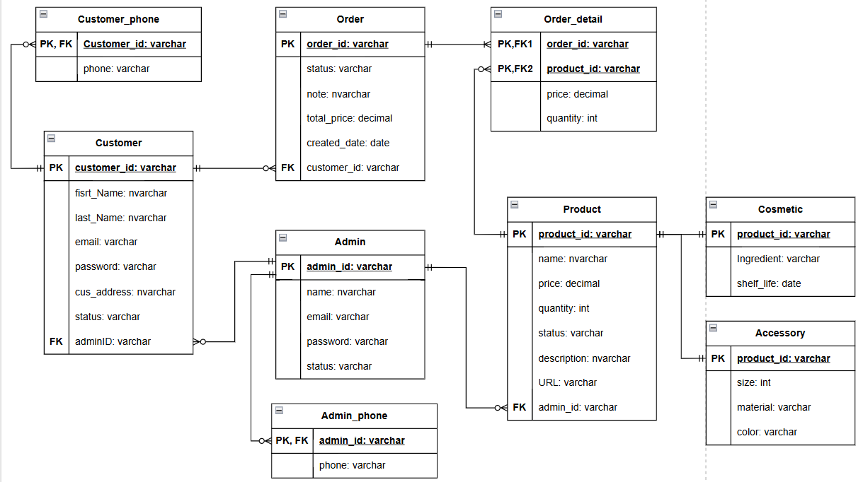

*Figure 9. ERM diagram*

### Table in database

*Table 1. Table Customer*

|  |  |  |  |
| --- | --- | --- | --- |
| **No.** | **Field Name** | **Type** | **Description** |
| 1 | ID | Int(11) | Primary key |
| 2 | Name | Varchar(50) | Customer name |
| 3 | Email | Varchar(50), unique | Customer email |
| 4 | Password | Hash(255) | Customer password |
| 5 | Address | Varchar(100) | Customer address |
| 6 | PhoneNumber | Varchar(10) | Customer phone number |
| 7 | Status | Enum(‘active’, ‘locked’) | Customer status |

*Table 2. Table Product*

|  |  |  |  |
| --- | --- | --- | --- |
| **No.** | **Field Name** | **Type** | **Description** |
| 1 | ID | Int(255) | Primary key |
| 2 | Name | Varchar(50) | Product name |
| 3 | Description | Text | Product description |
| 4 | Price | Decimal(10,2) | Product price |
| 5 | Image | Varchar(255) | Product image URL |
| 6 | InStock | BigInt(20) | Product in stock |
| 7 | Status | Enum(‘available’, ‘out of stock’) | Product status |
| 8 | CategoryID | Int(255) | Foreign key |
| 9 | CreateTime | Timestamp | Time create product |

*Table 3. Table Order*

|  |  |  |  |
| --- | --- | --- | --- |
| **No.** | **Field Name** | **Type** | **Description** |
| 1 | ID | Int(255) | Primary key |
| 2 | CustomerID | Int(11) | Foreign key |
| 3 | Date | Datetime | Order date |
| 4 | TotalPrice | Decimal(10,2) | Total Price |
| 5 | Note | Text | Ex: Only delivery in office hour |
| 6 | Status | Enum(‘active, ‘done’, ‘cancelled’) | Order status |

*Table 4. Table OrderDetail*

|  |  |  |  |
| --- | --- | --- | --- |
| **No.** | **Field Name** | **Type** | **Description** |
| 1 | ID | Int(255) | Primary key |
| 2 | OrderID | Int(255) | Foreign key |
| 3 | ProductID | Int(255) | Foreign key |
| 4 | Quantity | BigInt(255) | Total Price |
| 5 | Price | Decimal(10,2) |  |

*Table 5. Table Admin*

|  |  |  |  |
| --- | --- | --- | --- |
| **No.** | **Field Name** | **Type** | **Description** |
| 1 | ID | Int(255) | Primary key |
| 2 | Name | Varchar(50) | Admin name |
| 3 | Password | Hash(255) | Admin password |
| 4 | Email | Varchar(100), unique | Admin email |
| 5 | PhoneNumber | Varchar(10) | Admin phone number |
| 6 | Status | Enum(‘active’, ‘locked’) | Admin status |

## Introduction to ASP.NET Core

### Installation

Visit the official [.NET download page](https://dotnet.microsoft.com/download).

* Select the appropriate SDK version for your operating system.
* Download and run the installer.
* Verify the installation by opening a terminal or command prompt and running: “dotnet –version”. The output should display the installed .NET SDK version.

**For Visual Studio Users:**

* Download and install Visual Studio 2022.
* During installation, select the ASP.NET and web development workload.
* Once installed, open Visual Studio and create a new ASP.NET Core project.

### ASP.NET Core Project Structure

#### Root Directory

The root directory contains essential files and folders, including:

* Program.cs / Startup.cs: Entry point for configuring the application’s services and middleware pipeline.
* appsettings.json: Primary configuration file for application settings.
* wwwroot/: Static files such as CSS, JavaScript, and images.

#### Folders

* Controllers/: Contains controller classes that handle HTTP requests and responses. For example:

public class HomeController : Controller

{

public IActionResult Index()

{

return View();

}

}

* Models/: Houses data models that define the structure of your application’s data.
* Views/: Stores Razor view files used for rendering HTML pages. Example structure:
* Views/Home/Index.cshtml
* Views/Shared/_Layout.cshtml
* Data/: (Optional) Manages database-related operations, including context and migrations.

#### Key Files

* launchSettings.json: Configures application launch settings for different environments.
* Csproj File: Manages project dependencies and configurations.

#### Creating and Initializing the Project

* Open a terminal and navigate to your working directory.
* Generate a new project:

“dotnet new webapp -o MyProject

cd MyProject”

* Build and run the application:

“dotnet build

dotnet run”

Open the URL provided in your browser to test the application.

#### Configuring ASP.NET Core

**Application Settings**

* Edit appsettings.json to include custom configurations. Example:

{

“Logging”: {

“LogLevel”: {

“Default”: “Information”,

“Microsoft”: “Warning”,

“Microsoft.Hosting.Lifetime”: “Information”

}

},

“AllowedHosts”: “*”

}

**Middleware Setup**

* Modify Program.cs or Startup.cs to define middleware components. Example:

app.UseRouting();

app.UseEndpoints(endpoints =>

{

endpoints.MapControllers();

});

#### Running the Application

* Start the application: “dotnet run”
* Open the provided URL (e.g., https://localhost:5001) in a browser to verify successful deployment.

#### Advanced Configurations

**Enabling HTTPS**

* Check launchSettings.json for HTTPS settings:

“profiles”: {

“MyProject”: {

“commandName”: “Project”,

“launchBrowser”: true,

“applicationUrl”: “https://localhost:5001;http://localhost:5000”,

“environmentVariables”: {

“ASPNETCORE_ENVIRONMENT”: “Development”

}

}

}

**Database Integration**

* Install the necessary database package:

dotnet add package Microsoft.EntityFrameworkCore.SqlServer

* Update appsettings.json with a connection string:

“ConnectionStrings”: {

“DefaultConnection”: “Server=(localdb)\\mssqllocaldb;Database=MyDatabase;Trusted_Connection=True;”

}

## CRUD for Admin

### Create new category

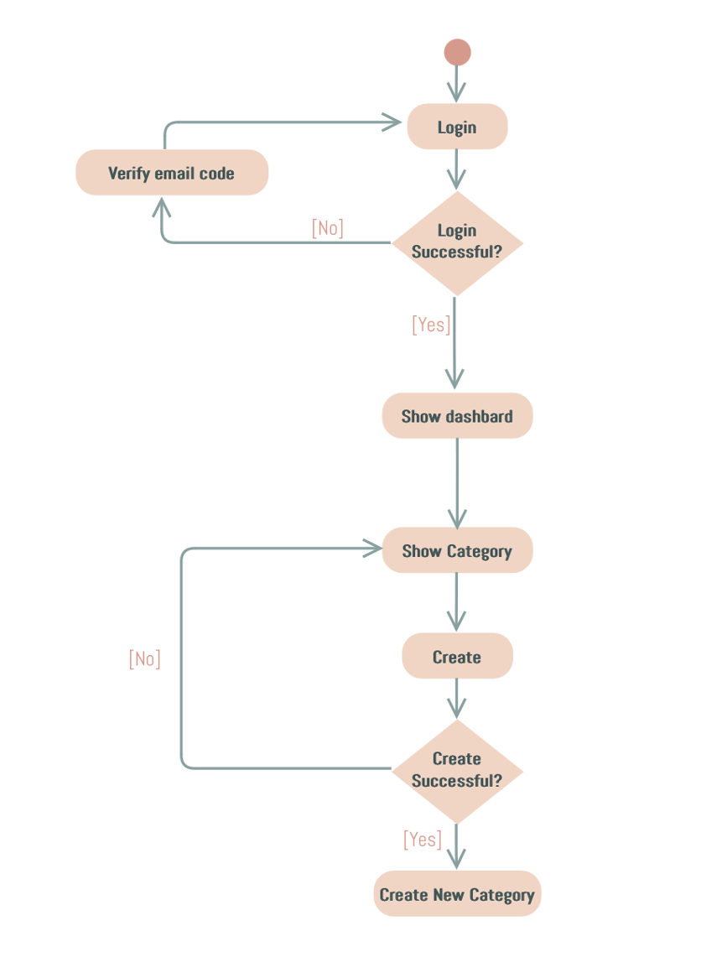

*Figure 10. Create activity diagram*

The activity diagram demonstrates the process for an admin to create a new category in the Anna Cosmetics system. The flow is as follows:

* **Login:** The admin starts by logging into the system.
* **Email Verification (if required):** If the login attempt is unsuccessful, the system may prompt the admin to verify their email code. Once verified, the login is retried.
* **Dashboard Access:** Upon successful login, the admin is directed to the dashboard where all management options are displayed.
* **Navigate to Categories:** The admin selects the category management feature to view existing categories.
* **Create Category:** The admin fills out the details for a new category and submits the form.
* **Validation:** The system verifies whether the category creation process is successful:
* If successful, a new category is added.
* If unsuccessful, the admin is prompted to reattempt the process.

### Read category

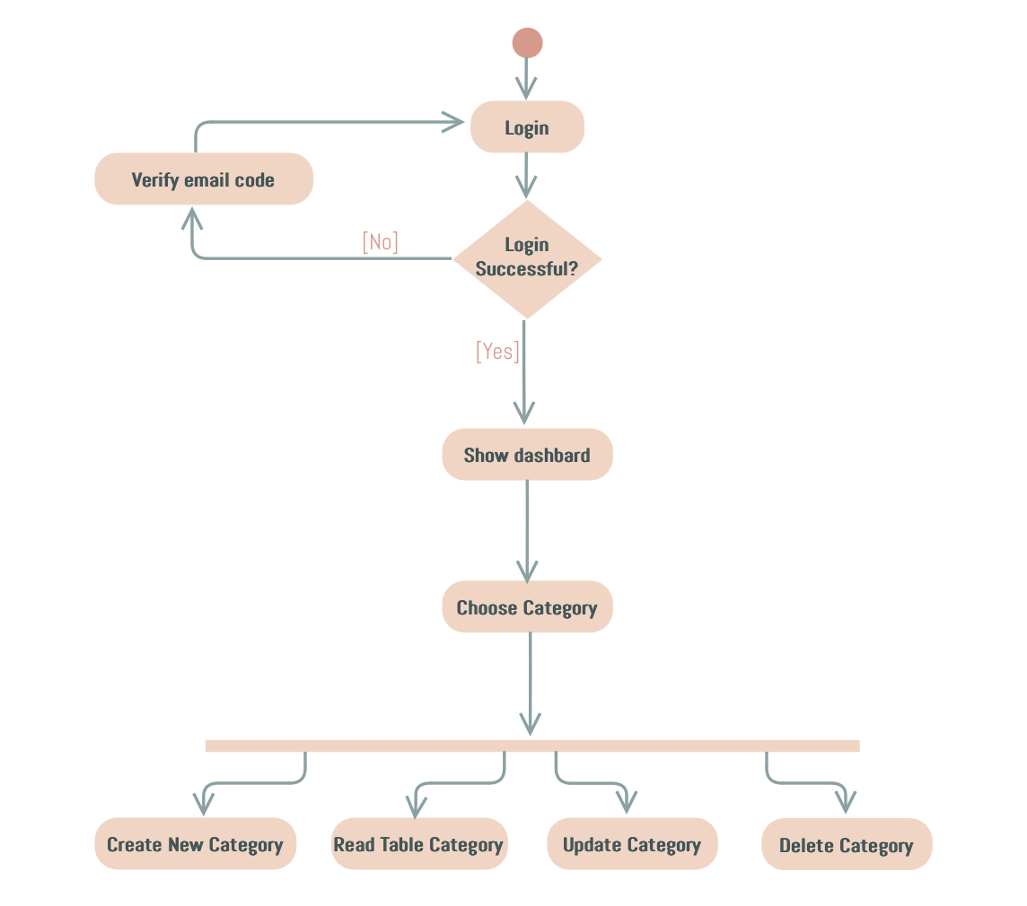

*Figure 11. Read activity diagram*

This activity diagram outlines the process for an admin to view category details in the Anna Cosmetics system. The flow proceeds as follows:

* **Login:** The admin begins by logging into their account.
* **Email Verification (if required):** If the login is unsuccessful, the system prompts the admin to verify their email code before attempting to log in again.
* **Access Dashboard:** Upon successful login, the admin is redirected to the dashboard where all management options are displayed.
* **Choose Category Management:** The admin selects the category management section to view the list of available categories.
* **Read Category Details:** The admin reviews the table containing all existing categories, including details such as category names, descriptions, and statuses.

### Update category

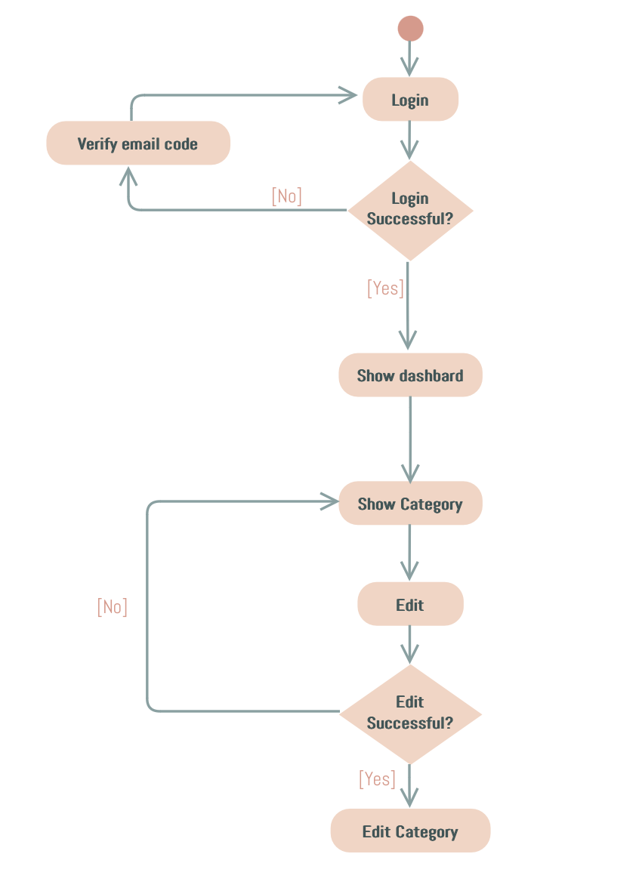

*Figure 12. Edit activity diagram*

This activity diagram outlines the steps an admin takes to edit a product category in the Anna Cosmetics system. The flow is described as follows:

* **Login:** The admin begins by logging into the system.
* **Email Verification (if required):** If the login attempt fails, the system prompts the admin to verify their email code before retrying the login process.
* **Access Dashboard:** Upon successful login, the admin is directed to the dashboard where all management options are accessible.
* **Navigate to Categories:** The admin selects the category management option to view the list of existing categories.
* **Edit Category:** The admin selects a specific category to modify its details and submits the changes.
* **Validation:** The system verifies the success of the edit operation:
* If the edit is successful, the changes are saved, and the updated category is displayed.
* If the edit fails, the admin is prompted to retry.

### Delete category

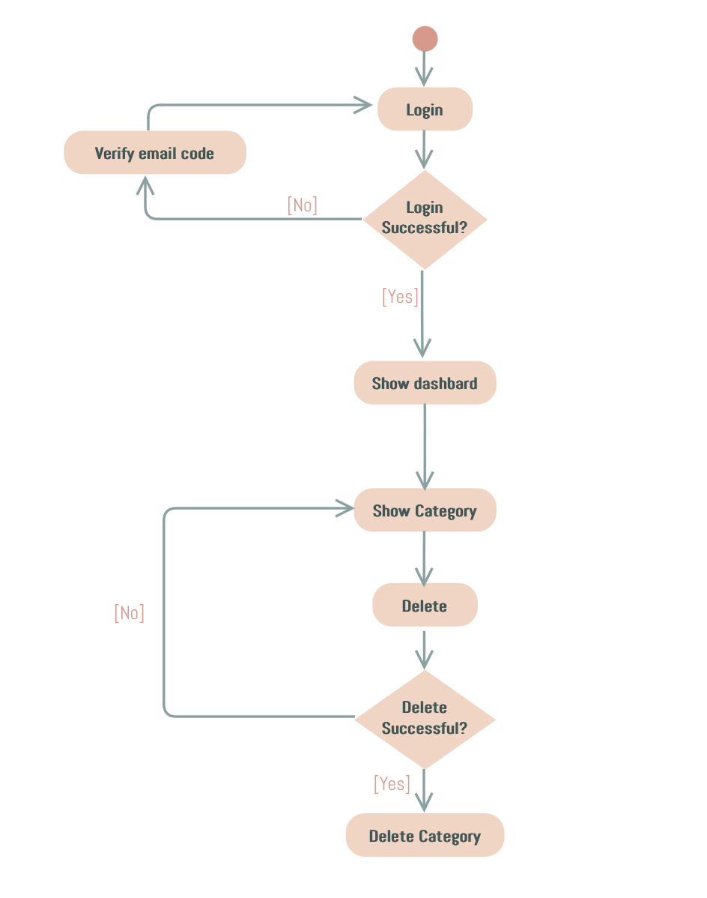

*Figure 13. Delete activity diagram*

This activity diagram represents the process an admin follows to delete a category in the Anna Cosmetics system. The flow is as follows:

* **Login:** The admin begins by logging into the system.
* **Email Verification (if required):** If the login fails, the system requests email verification before allowing the admin to retry logging in.
* **Access Dashboard:** Upon successful login, the admin is directed to the dashboard where management options are available.
* **Navigate to Categories:** The admin selects the category management section to view the list of available categories.
* **Delete Category:** The admin selects a category to delete and initiates the deletion process.
* **Validation:** The system checks if the category was successfully deleted:
* If successful, the category is permanently removed from the database.
* If unsuccessful, the admin is prompted to retry the deletion process.

# EXPERIMENT AND DISCUSSION

This chapter presents the practical implementation of the project, including the setup of the development environment, the outcomes of the system's functionalities, and an analysis of the results. It evaluates the effectiveness of the implemented features and discusses their performance based on real-world testing scenarios.

## Installation Environment

* Microsoft Visual Studio Community 2022 (64-bit) – Current Version: 17.12.3
* .NET SDK Version 9.0.101
* MySQL Version 8.0.40 (64 bits)
* GitHub Desktop Version 3.4.9 (arm64)
* ApacheFriends XAMPP Version 8.0.30

## Results and Discussion

### Home page for customer

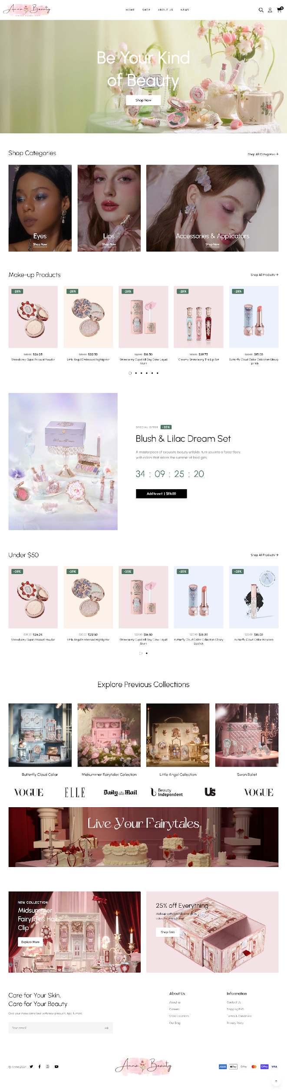

*Figure 14. Home page*

The home page of the Anna Cosmetics website is designed to offer a seamless and engaging shopping experience by integrating multiple interactive blocks that facilitate product discovery and smooth navigation. The interface includes distinct sections for featured products, shop categories, search functionality, and promotional countdowns, all contributing to an intuitive user experience. Below is a detailed breakdown of the interface and features implemented, along with an evaluation of their functionality and performance.

#### Interface and Features Implemented

**Product Blocks (Makeup & Under $50)**

* **Description:** The home page is segmented into dedicated product blocks, including one for Makeup Products and another showcasing products Under $50. These blocks allow users to quickly explore curated collections without navigating the entire catalog.
* **Implemented Features:**
* Displays product images, names and prices for each item.
* Hover effects reveal interactive buttons such as “Add to Cart” and “Compare.”
* Clicking on any product navigates the user directly to the Product Detail page.
* **Evaluation:** The product blocks are visually appealing and intuitive, enabling users to discover items effortlessly. Enhancements like smoother hover animations and confirmation messages when adding items to the cart could further improve the experience.

**Shopping Categories Block**

* **Description:** A dedicated section on the home page presents various shop categories, allowing users to explore different product ranges. Each category is represented by an image or icon along with a brief description.
* **Implemented Features:**
* Displays categories with a “Shop Now” button for immediate navigation.
* Clicking “Shop Now” or the category icon redirects the user to the Shop page, where related products are displayed.
* **Evaluation:** This block effectively directs users to explore the full product range. The clear layout enhances navigation, and adding more visual cues could further increase user engagement.

**Search Functionality**

* **Description:** A prominently placed search bar enables users to quickly find products by entering either product names or category keywords.
* **Implemented Features:**
* Supports keyword search for products and categories.
* Pressing Enter or clicking the search icon navigates users to the Shop page with relevant search results.
* **Evaluation:** The search functionality is efficient and user-friendly. Incorporating auto-suggestions or real-time filtering could further enhance the search experience.

**Countdown Block for New Product Release**

* **Description:** This block highlights new product releases by featuring a countdown timer, which creates urgency and excitement among users by indicating the time remaining until the product launch.
* **Implemented Features:**
* Displays a dynamic countdown timer (days, hours, minutes, seconds) for the upcoming release.
* Showcases promotional details such as discount rates and a brief product description.
* Includes an “Add to Cart” button for immediate action.
* **Evaluation:** The countdown block effectively generates a sense of urgency, enhancing the promotional impact of new releases. Future improvements could include additional visual effects or notifications as the countdown nears its end.

**Navigation and Interactive Elements**

* **Description:** The overall home page layout is designed to be responsive and interactive, ensuring a smooth transition from product discovery to detailed viewing and purchasing actions.
* **Implemented Features:**
* Interactive elements (hover effects, clickable product images) that guide users to appropriate pages such as Product Detail, Shop, or Compare.
* Responsive design ensures consistency across various devices and screen sizes.
* **Evaluation:** These features significantly enhance user engagement and ease of navigation. Ongoing testing and optimization will ensure that performance remains efficient across different devices.

**Enhanced User Experience**

* **Description:** The interface incorporates several user-focused improvements to increase convenience and accessibility.
* **Implemented Features:**
* Utilization of lazy loading to ensure quick load times for images and product information.
* A clear and well-organized navigation menu that facilitates easy access to various categories and products.
* **Evaluation:** These enhancements contribute to a highly user-friendly home page by preventing common input errors and ensuring rapid content delivery without sacrificing quality.

**Mobile-Friendly Design**

* **Description:** The interface is fully responsive and optimized for mobile devices, ensuring a consistent user experience across various screen sizes.
* **Implemented Features:**
* Adaptive layouts that automatically adjust to different screen resolutions.
* Touch-friendly navigation elements and buttons designed specifically for mobile users.
* **Evaluation:** Mobile optimization significantly improves accessibility and expands the user base. While the loading speed is commendable, further testing on older devices may reveal additional optimization opportunities.

#### Overall Evaluation

The Anna Cosmetics home page offers an intuitive, responsive shopping experience. Interactive sections - including product blocks for Makeup and Under $50 items, a clear shop categories block, and efficient search functionality - allow users to quickly navigate and discover products. A dynamic countdown for new releases creates urgency, while hover effects and clear navigation cues seamlessly guide users to detailed views, the Shop page, and the Compare section.

Enhanced features such as lazy loading and a clean, organized menu improve performance, and the mobile-friendly design ensures consistent accessibility across devices. Overall, the home page meets modern e-commerce needs, with potential for further enhancements like personalized recommendations and advanced filtering to boost engagement even more.

### Login / Logout for Customer

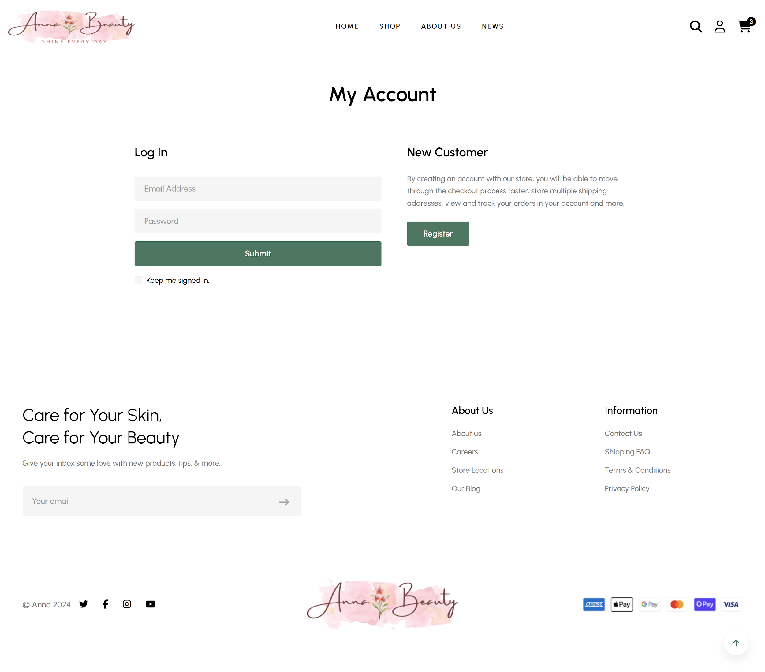

*Figure 15. Login page*

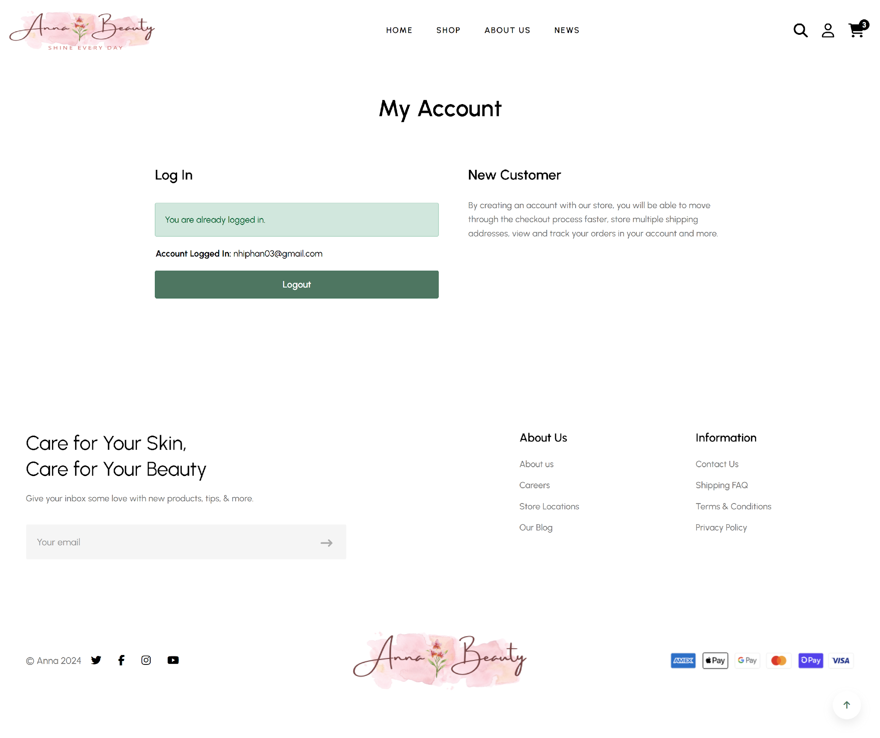

*Figure 16. My account/ Logout page*

This section introduces the Login/Logout functionality, which provides secure user authentication on the Anna Cosmetics website. It enables users to access their accounts using email and password, while allowing safe termination of sessions. The following subsections detail the interface and features implemented, along with an overall evaluation of its performance and security.

#### Interface and Features Implemented

* **Description:** The Login page is designed to enable secure user authentication by allowing users to enter their email and password. It features real-time validation, providing immediate feedback for invalid inputs. If the email format is incorrect, the user is prompted to correct it. If the email does not exist or the password is incorrect, appropriate error messages are displayed. Upon successful login, the user’s account information is shown and the "Register" button is hidden to prevent duplicate registrations. When the user logs out, a confirmation message is displayed, and the login and register options are restored, allowing for new account access or registration.
* **Implemented Features:**
* Authentication Process: The system validates the email format, displaying an error if incorrect, checks whether the email exists (notifying if it doesn't), and verifies the password, showing an error if it is incorrect.
* User Session Management: Upon successful login, user account information is displayed and the "Register" button is hidden to prevent duplicate registrations. Conversely, when the user logs out, a "Logout Successful" message appears and the "Submit" (login) and "Register" buttons are restored, allowing for new logins or account creation.
* **Evaluation:** The login interface is intuitive and provides clear, real-time feedback through specific error messages (e.g., for invalid email formats, non-existent accounts, or incorrect passwords), which enhances usability and reduces confusion. The dynamic removal of the registration button upon successful login streamlines the user experience by preventing duplicate registrations. Additionally, the straightforward logout process reassures users and restores access to login options. Future enhancements, such as password recovery and two-factor authentication, could further improve security and user trust.

#### Overall Evaluation

Overall, the Login/Logout functionality on the Anna Cosmetics website offers a secure and user-friendly experience. The system effectively validates inputs, displays clear error messages, and smoothly transitions between logged-in and logged-out states. These features collectively contribute to a reliable authentication process that enhances user confidence. Future improvements - such as incorporating password recovery and advanced security measures - could further bolster the functionality and overall user experience.

### Register for customer

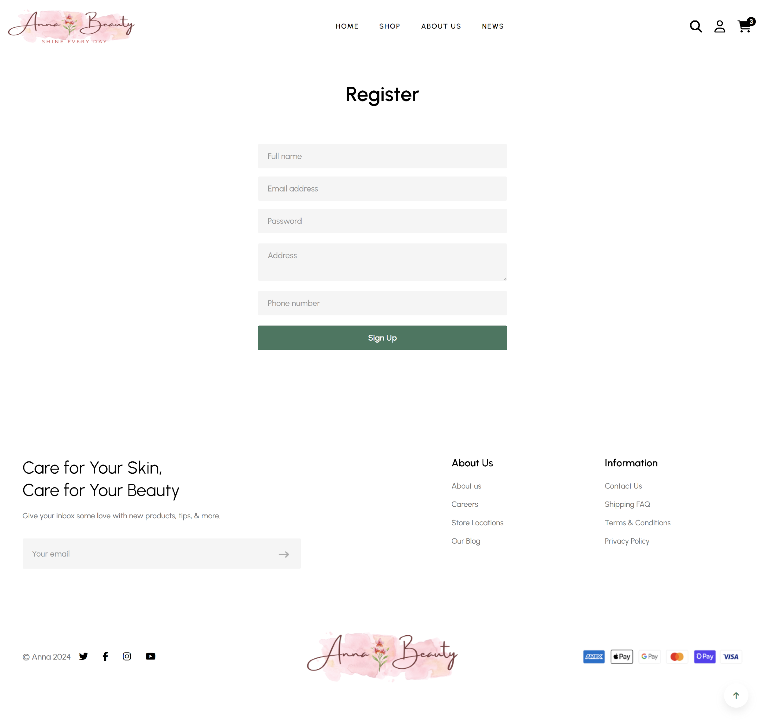

*Figure 17. Register page*

This section introduces the registration functionality, which allows new users to create an account on the Anna Cosmetics website. By entering their personal details, users can establish a profile and gain access to personalized shopping features.

#### Interface and Features Implemented

* **Description:** The Register page prompts users to provide essential information, including full name, email address, password, address, and phone number. Once the form is submitted, a new account is created, enabling users to log in and manage their profile or orders.
* **Implemented Features:**
* Real-Time Validation: The system checks for a valid email format, ensures that the password meets required criteria (such as minimum length or character types), and notifies users if any mandatory fields are left empty.
* Duplicate Account Detection: If the email address already exists in the system, an error message prompts the user to either log in or use a different email to create an account.
* User Account Creation: Upon successful registration, users are directed to the login page and informed with a confirmation message (e.g., “Account created successfully”), allowing them to access personalized features.
* **Evaluation:** The registration process is straightforward, guiding users with clear field labels and error messages to prevent invalid inputs. Real-time validation enhances usability by catching common mistakes (e.g., invalid email format) before submission. Duplicate account detection helps maintain data integrity and avoids confusion for returning customers. Future improvements could include stronger password criteria or an email verification step to further enhance security and user trust.
* Stronger Password Criteria: Enforcing stronger password rules (e.g., requiring a mix of uppercase letters, special characters, and numbers) would increase account security.
* Email Verification: Implementing an email verification process can enhance security by confirming the validity of the user’s email address and preventing fraudulent account creation.
* CAPTCHA Integration: Adding a CAPTCHA feature would protect against bot-driven registration attempts, ensuring only genuine users can sign up.

#### Overall Evaluation

Overall, the Register page provides a user-friendly interface for new account creation on the Anna Cosmetics website. By combining real-time validation with clear error messages, it ensures a smooth onboarding experience. The system effectively guides users through the registration process, helping prevent common mistakes and improving overall user satisfaction. While the current functionality meets basic requirements, additional security measures such as email verification and multi-factor authentication could further protect user data and enhance trust in the platform. Furthermore, future enhancements such as improved password policies and CAPTCHA integration will help safeguard accounts and ensure a more secure registration experience.

### Shop page

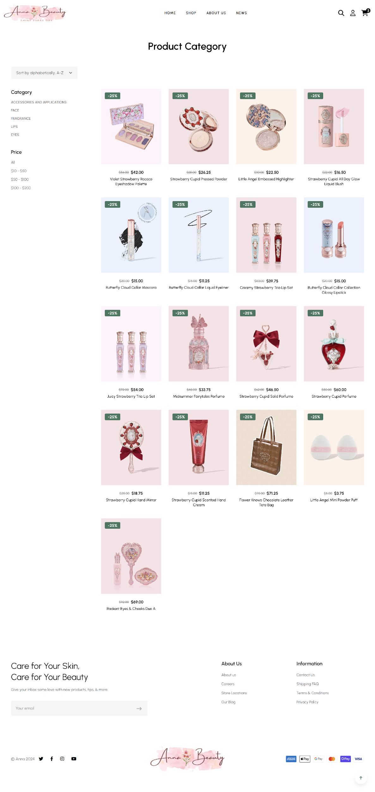

*Figure 18. Product category page*

This section introduces the Shop page of the Anna Cosmetics website, designed to provide customers with an easy way to browse and search through all available products, with options to sort them based on various criteria. Customers can also add products to the cart or compare them with others in the same category.

#### Interface and Features Implemented

* **Description:** The Shop page displays all products from different categories available in the database. Users can sort products by name (alphabetically), category, or price. The page also includes a search bar for searching products by name or category. By clicking on a product, users are directed to the product detail page. Hovering over a product image reveals two interactive buttons: “Add to Cart” and “Compare.” This makes browsing more convenient and interactive for customers.
* **Implemented Features:**
* Product Display: The Shop page dynamically displays all available products from various categories, including images, names, and prices.
* Sorting Options: Products can be sorted alphabetically, by category, or by price to meet user preferences.
* Search Functionality: Users can search for products by name or category using a search bar, allowing for quick access to desired products.
* Interactive Features: Clicking on any product image or name navigates users to the product detail page. When hovering over a product image, two options appear: Add to Cart, which allows users to add the product to their shopping cart without leaving the Shop page, and Compare, which redirects users to a comparison page where they can compare the selected product with other items from the same category.
* **Evaluation:**
* Usability: The page is well-structured and easy to navigate, enabling users to quickly filter through products based on their preferences. The clear layout of product images, names, and prices helps customers make informed decisions. The hover effect that displays the “Add to Cart” and “Compare” buttons enhances interactivity.
* Search & Sorting: Sorting options improve user navigation by allowing them to focus on their preferred criteria (alphabetical order, price range, or category). The search function is highly efficient, enabling users to locate specific products easily.
* Product Interaction: The ability to hover over product images for quick actions such as adding to the cart or comparing products is highly convenient. The “Compare” feature is especially useful, though additional instructions or highlights could help users understand how to use it more effectively.

#### Overall Evaluation

The Shop page on the Anna Cosmetics website offers an efficient and user-friendly shopping experience, with easy navigation, helpful search, and sorting features. The interaction options, such as adding products to the cart and comparing items, enhance the overall experience and streamline the purchasing process. While the current design works well for most users, future updates could include additional filtering options (e.g., by rating or brand) and a “quick view” feature that allows users to view product details without leaving the page.

### Product detail page

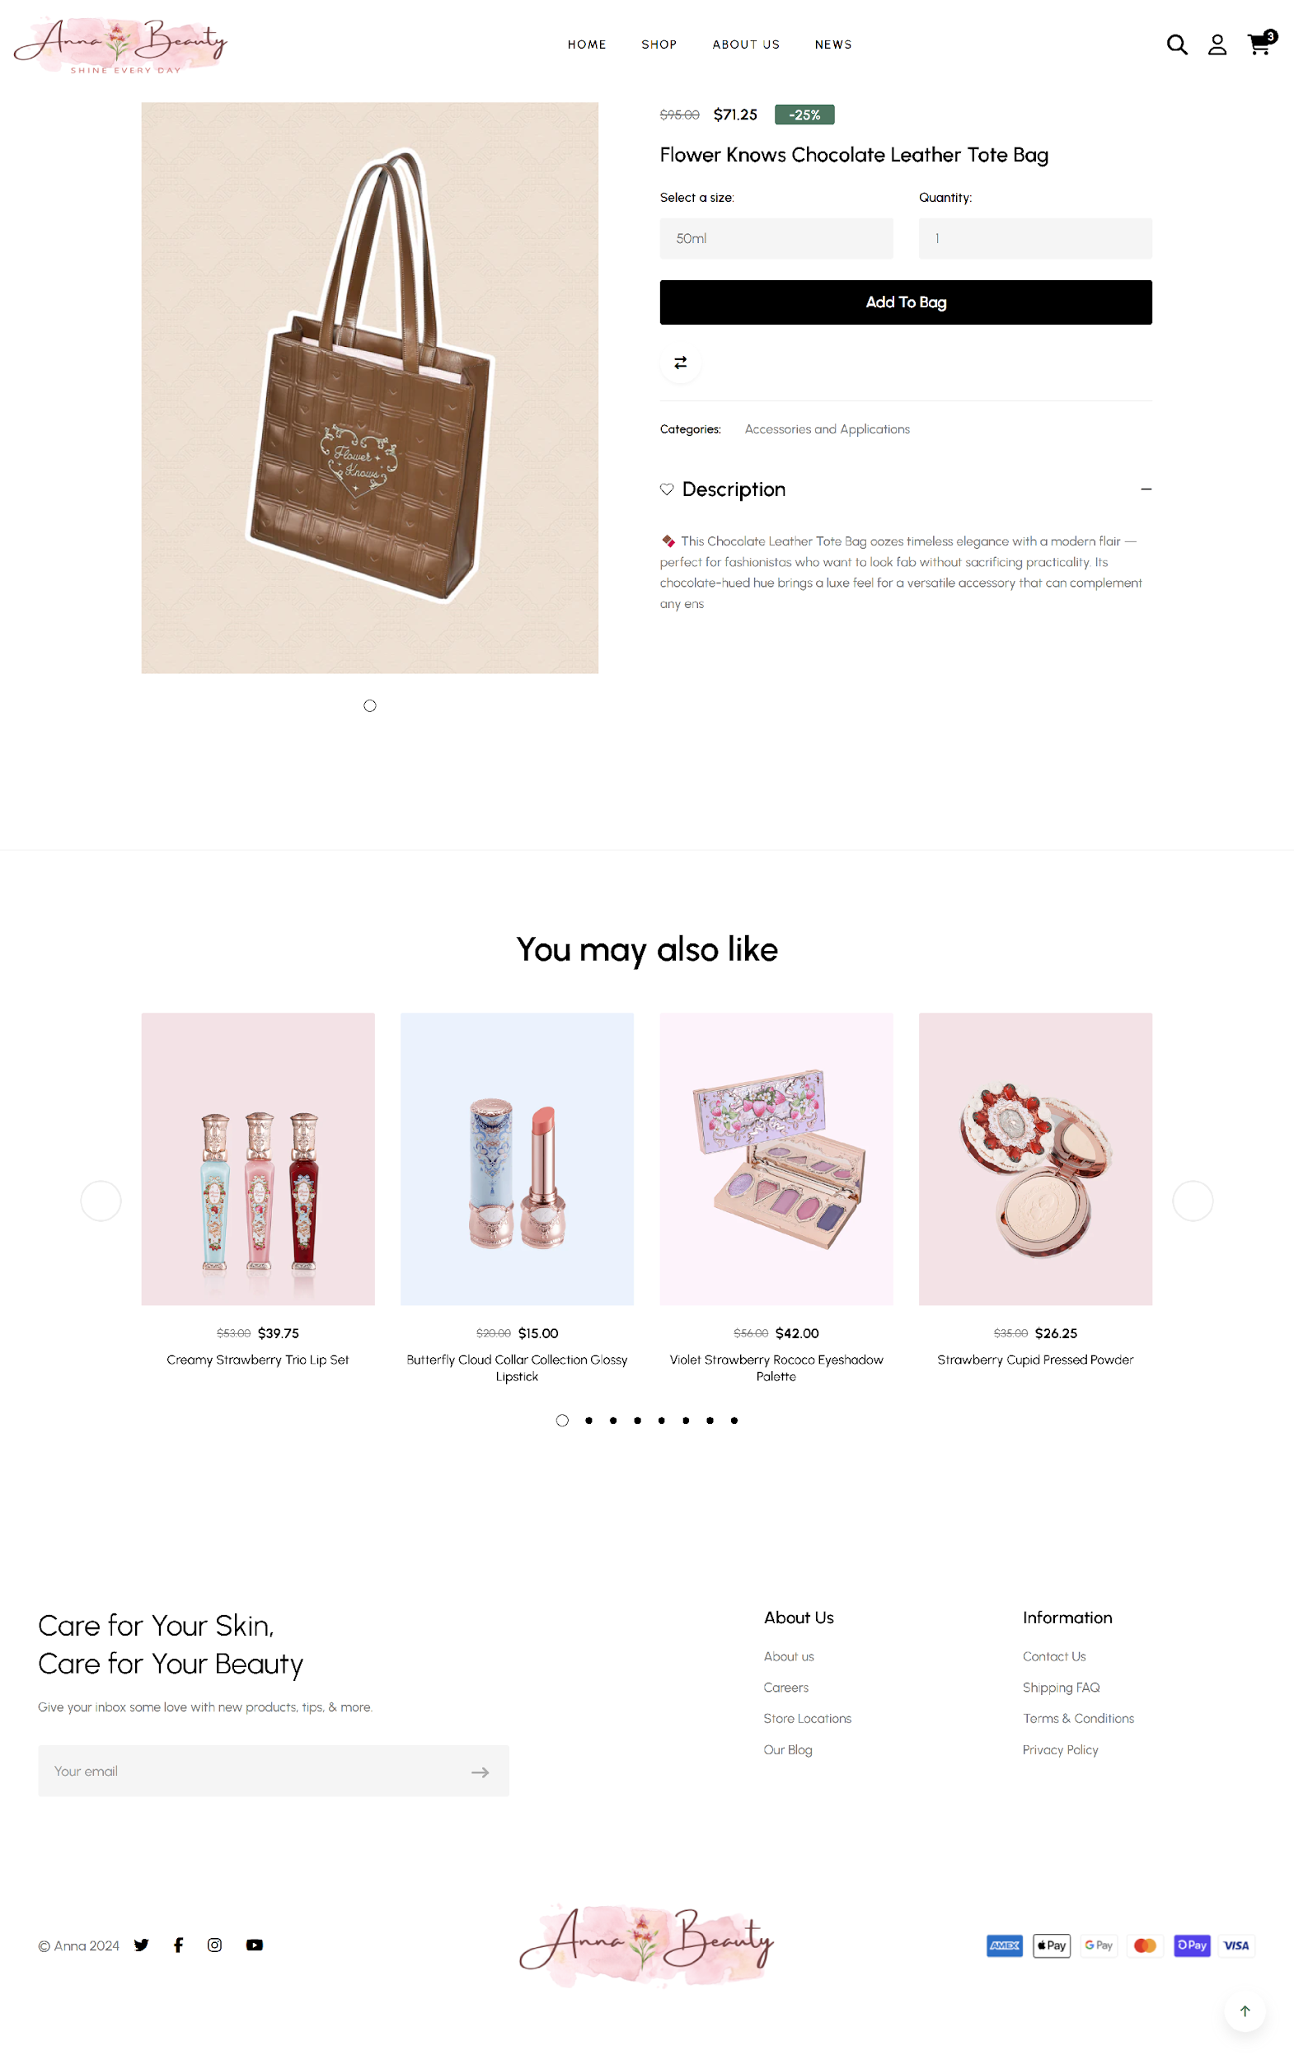

*Figure 19. Product Detail page*

This section introduces the Product Detail page of the Anna Cosmetics website, designed to offer detailed information about individual products. Customers can view product descriptions, images, pricing, and options such as size or quantity selection. The page also allows users to add products to their cart or explore other similar products.

#### Interface and Features Implemented

* **Description:** The Product Detail page displays a comprehensive view of a selected product, including high-quality images, a detailed description, price, available sizes or variations, and an "Add to Bag" button. Users can select product quantities and sizes, and they are encouraged to explore related products through a “You May Also Like” section. The design focuses on providing all relevant details to help users make an informed purchasing decision.
* **Implemented Features:**
* Product Information: Includes detailed product images, descriptions, price, and options (e.g., size and quantity).
* Size & Quantity Selection: Allows users to choose product variations (such as size) and the quantity they wish to purchase.
* Add to Cart: An “Add to Bag” button enables users to easily add the product to their shopping cart without navigating away from the page.
* You May Also Like: A carousel of recommended products from similar categories is displayed to encourage users to explore more items.
* Navigation: Users can return to the Shop page or continue shopping with clear, accessible navigation options.
* **Evaluation:**
* User Experience: The page is structured to provide a clear and user-friendly layout. Product images are high quality and allow users to see the product from different angles. The detailed descriptions ensure that users have all the information they need to make an informed decision.
* Interaction: The “Add to Bag” functionality is seamless, allowing users to add products to their cart without leaving the page. The “You May Also Like” section enhances cross-selling by suggesting relevant products.
* Visual Appeal: The design of the Product Detail page is visually appealing and supports a smooth shopping experience. The layout is clean, and the use of interactive elements such as the size and quantity selectors adds to the user’s ability to customize their shopping experience.
* Improvements: Future improvements could include adding user reviews and ratings for products, as well as the option for users to ask questions or view FAQs related to each product.

#### Overall Evaluation

The Product Detail page effectively provides all necessary information and features to support a smooth, informative, and engaging shopping experience. The integration of product details, size/quantity options, and related product suggestions enhances the overall usability of the site. As the site continues to evolve, further features such as product reviews, stock availability, and more advanced filtering could further enhance the experience for users.

### Compare page

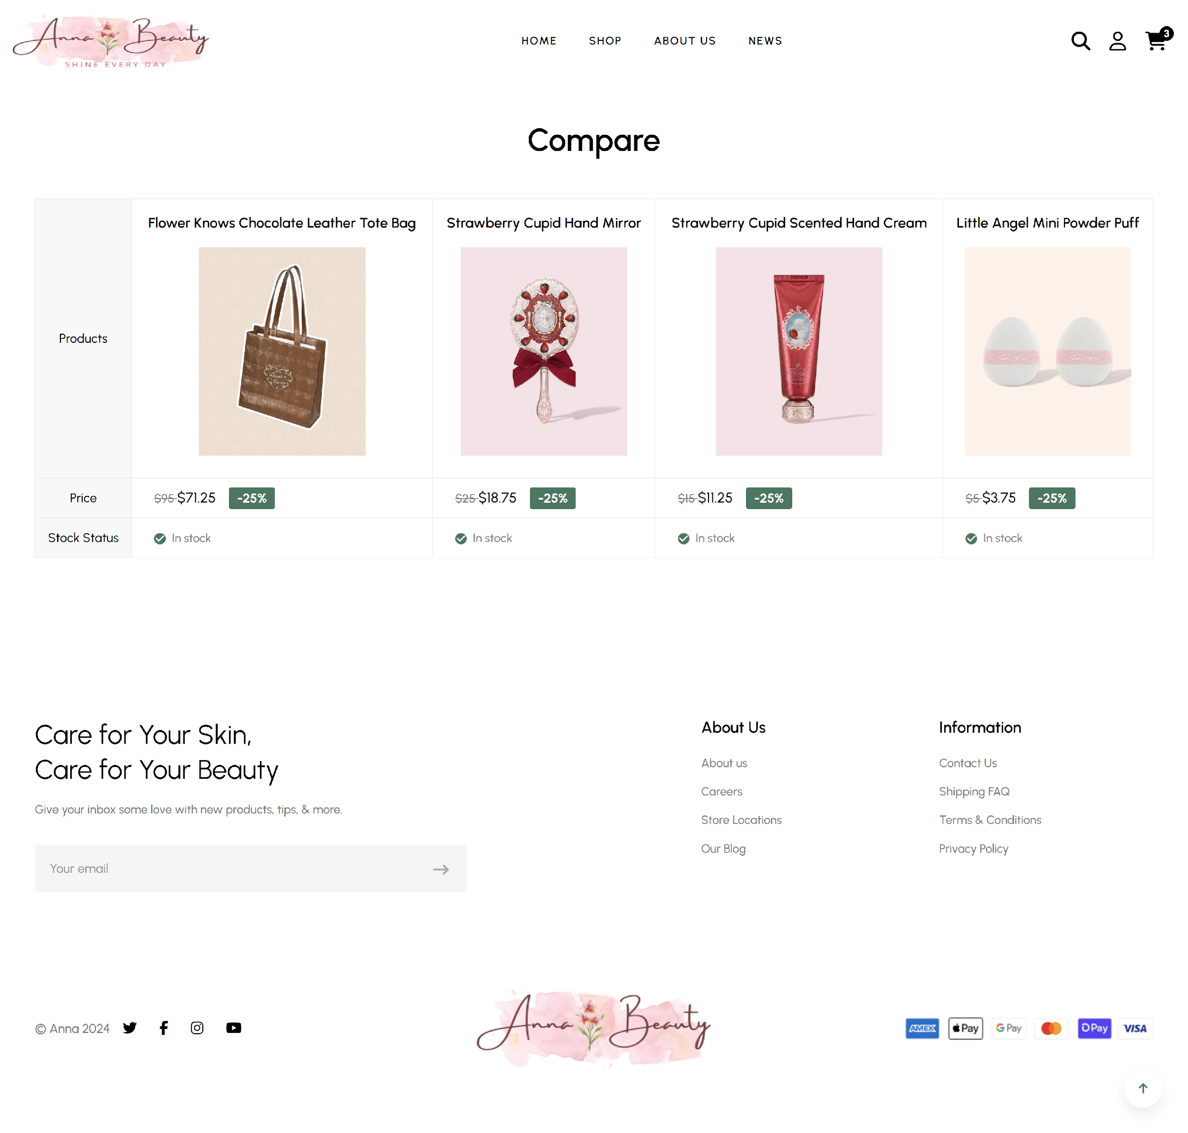

*Figure 20. Compare page*

This section introduces the "Compare" page of the Anna Cosmetics website, allowing customers to compare multiple products side by side. It helps users make informed purchasing decisions by displaying key details of selected products, such as their price, stock status, and any ongoing discounts.

#### Interface and Features Implemented

* **Description:** The Compare page allows users to select multiple products for comparison, displaying them side by side. Each product’s image, price, stock status, and discount percentage are shown clearly. This feature enables customers to assess product differences and make the best choice based on their preferences.
* **Implemented Features:**
* Product Display: Products added to the comparison list are displayed side by side, with product images, prices, stock statuses, and discount information clearly visible.
* Price and Discount Information: Each product shows its original price, discounted price (if applicable), and percentage discount, making it easy for users to compare prices.
* Stock Status: Displays whether the product is in stock, which helps users understand product availability.
* Add to Cart: Users can click on the “Add to Cart” button to quickly add any product from the comparison to their shopping cart.
* **Evaluation:**
* Usability: The Compare page is easy to use, with a clear layout that shows products in a side-by-side comparison format. Users can quickly evaluate products based on important factors like price, availability, and discounts.
* Clarity: The price, discount, and stock status information is clearly displayed for each product, making it easy for users to compare the products and decide which one to purchase.
* User Engagement: The “Add to Cart” button under each product facilitates quick decision-making and allows users to add their selected products to their shopping cart without navigating away from the page.
* Future Improvements: Future enhancements could include adding more detailed specifications (e.g., product dimensions, materials, or customer ratings) to further aid in product comparison. Additionally, enabling users to add more than four products to the comparison list could offer greater flexibility.

#### Overall Evaluation

The Compare page on the Anna Cosmetics website enhances the shopping experience by allowing customers to easily compare multiple products. This feature simplifies decision-making and improves user experience by providing key product details in an accessible format. While the current version meets the core needs, future updates could include expanding the product comparison options and adding more detailed information about the products to increase its usefulness.

### About Us page

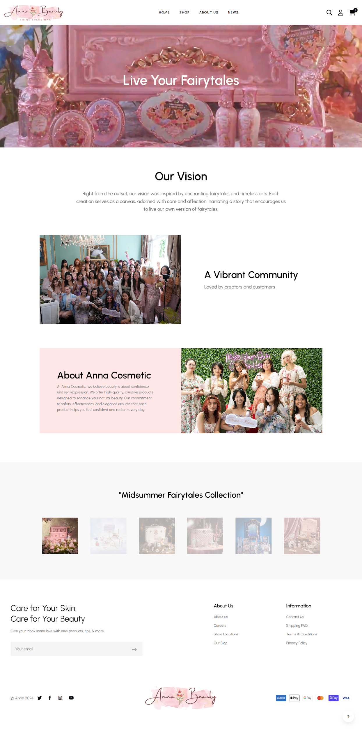

*Figure 21. About Us page*

This section introduces the "About Us" page of the Anna Cosmetics website, providing customers with insight into the company’s vision, community, and the values that drive its creation of high-quality cosmetic products.

#### Interface and Features Implemented

* **Description:** The "About Us" page offers an overview of Anna Cosmetics, focusing on the company's vision, community, and commitment to beauty and self-expression. The page is structured to engage visitors through a compelling narrative and visually appealing elements. It includes the company’s vision, a section on the vibrant community it has built, and information about the brand’s philosophy. Additionally, the page highlights the "Midsummer Fairytales Collection," showcasing featured products.
* **Implemented Features:**
* Vision Statement: The page prominently displays the company’s vision, emphasizing inspiration from fairytales and timeless arts, which guides the brand’s creative process.
* Community Section: A section showcasing the vibrant and inclusive community around Anna Cosmetics, featuring photos of creators and customers who are part of the brand’s journey.
* About Anna Cosmetics: An informative section that explains the brand’s values, including its commitment to confidence, safety, and elegance in beauty products.
* Featured Product Collection: Highlights the "Midsummer Fairytales Collection" through a visual display of featured products, encouraging visitors to explore the collection.

#### Overall Evaluation

The "About Us" page on the Anna Cosmetics website provides an engaging and informative experience for users. It successfully communicates the company’s core values and vision, while also fostering a sense of community. The design is visually appealing, with a well-organized layout that makes it easy for users to navigate through the various sections. The inclusion of high-quality images of the community and products adds authenticity and emotional appeal, enhancing the user connection with the brand. Future improvements could include adding customer testimonials or additional interactive elements to further engage visitors.

### Category page for admin panel

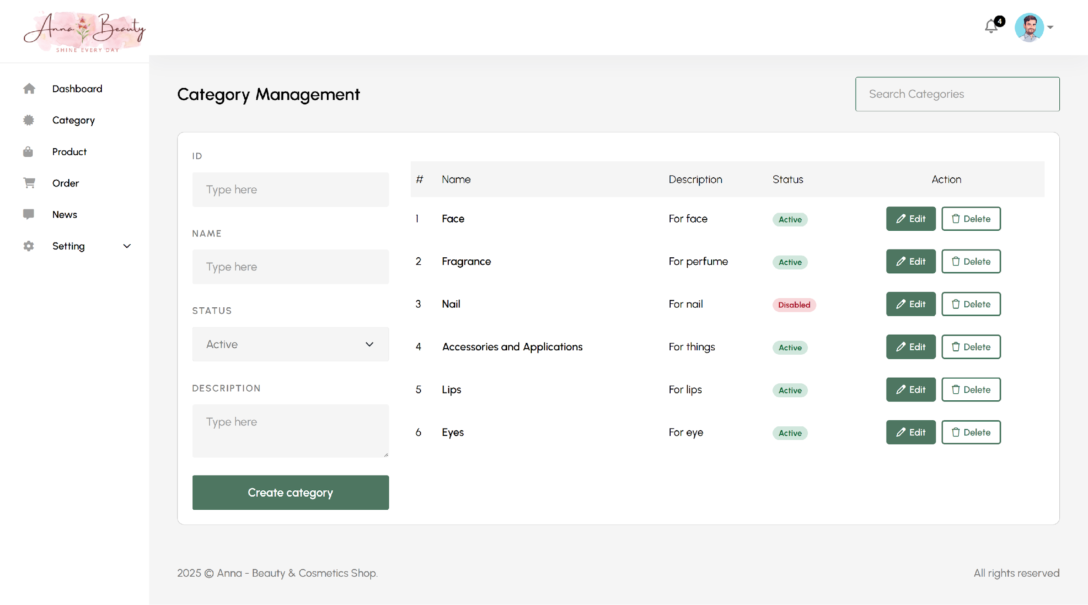

*Figure 22. Category Management page*

This section presents the Category Management interface, allowing the admin to manage the product categories in the system. The admin can perform CRUD operations (Create, Read, Update, Delete) on product categories to maintain the site’s organization and keep it up to date.

#### Create Category

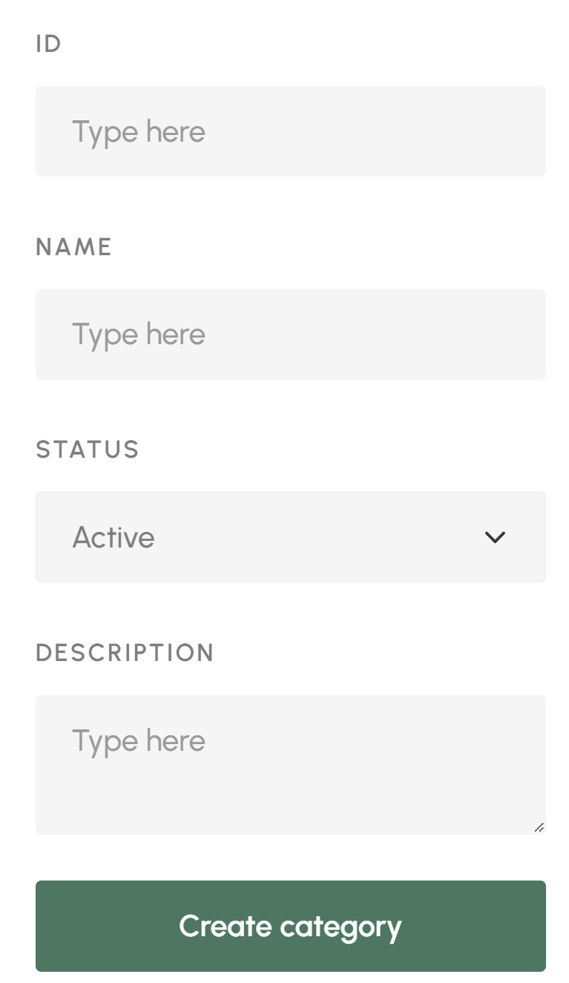

*Figure 23. Create category interface*

* **Description:** The “Create Category” feature allows the admin to add new product categories to the system. Admins can define the category name, description, and set its status (active or inactive). This feature helps in organizing products effectively based on their categories.
* **Implemented Features:**
* Form fields for entering the category name, description, and setting its status (active/inactive).
* “Create category” button to add the new category to the database.
* **Evaluation:** The Create Category feature is simple to use, offering an easy interface for adding new categories. The form's structure ensures that all necessary fields are covered. The feature is functional and serves the purpose of adding new product categories efficiently.

#### Read

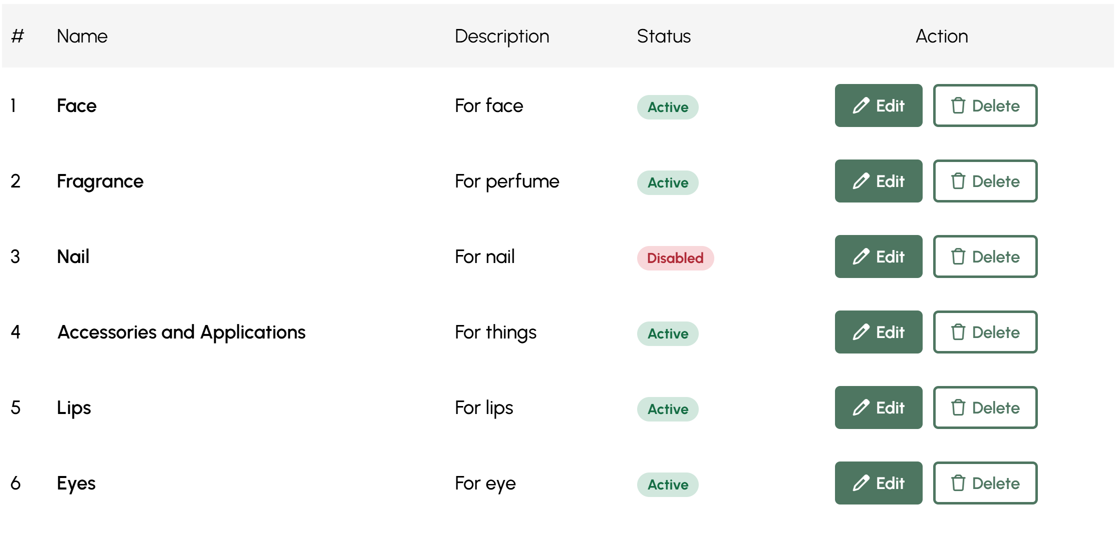

*Figure 24. Read category interface*

* **Description:** The “Read” interface displays all categories already present in the database. The admin can view the name, description, and status of each category. This provides an overview of the categories that have been created.
* **Implemented Features:**
* A table listing category names, descriptions, and their active/inactive status.
* Search functionality to filter categories.
* **Evaluation:** The “Read” interface is intuitive, providing a clear view of all categories. The table format makes it easy to read and find specific categories. The search feature helps in quickly locating a category among many.

#### Update

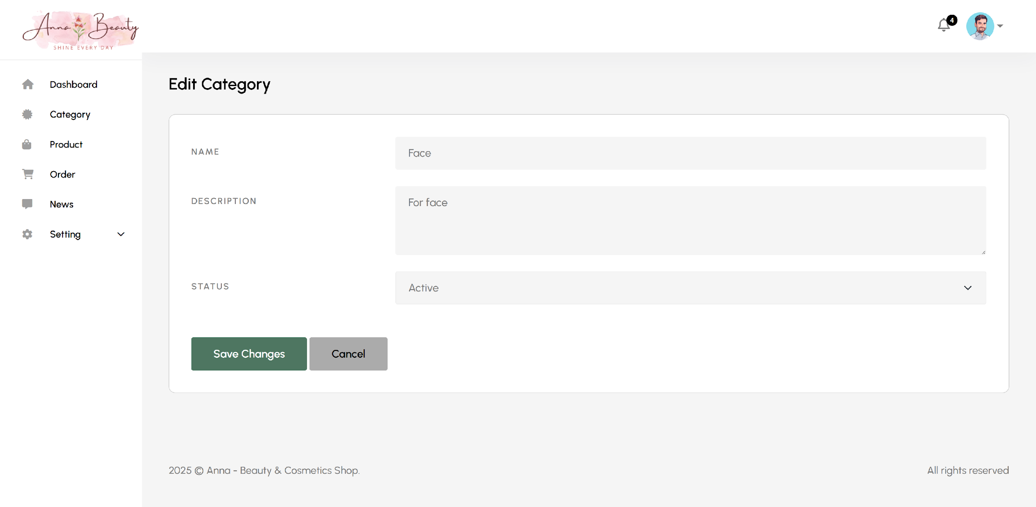

*Figure 25. Update category interface*

* **Description:** The “Update” feature enables the admin to modify the details of any category, such as name, description, or status. This is useful when changes are required for an existing category.
* **Implemented Features:**
* Fields to edit category name, description, and status.
* A "Save Changes" button to apply updates to the category.
* **Evaluation:** The “Update” interface is straightforward, providing the admin with easy access to modify category details. The process is simple and efficient, allowing for quick updates to existing categories.

#### Delete

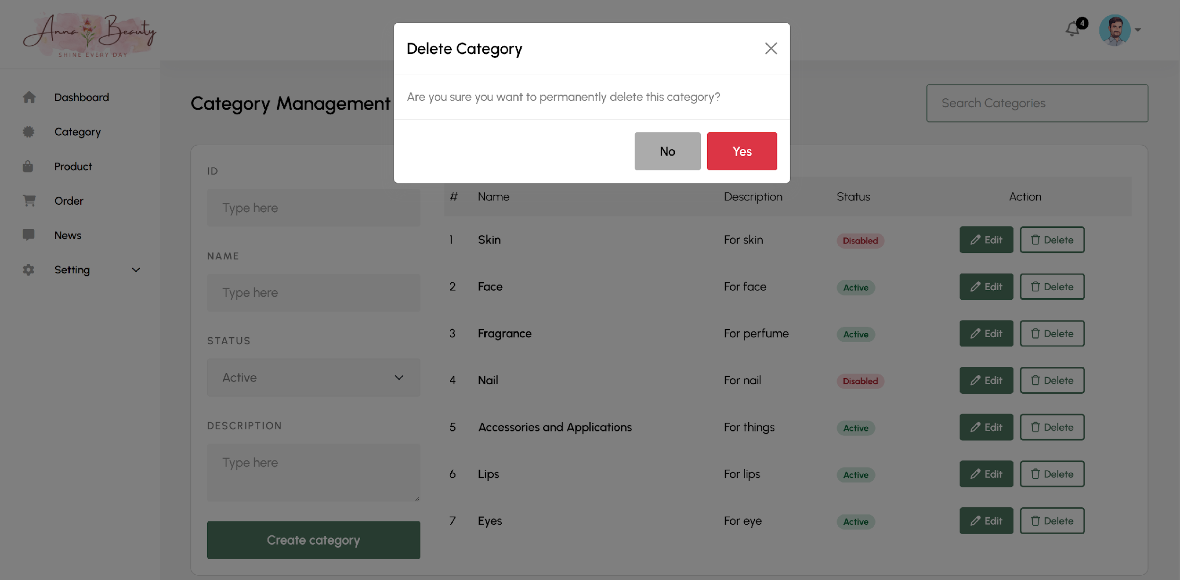

*Figure 26. Delete category interface*

* **Description:** The “Delete"” feature allows the admin to permanently remove a category from the database. When a category is deleted, all associated products should either be reassigned or deleted as well.
* **Implemented Features:**
* A “Delete” button next to each category entry in the list.
* A confirmation popup to ensure that the deletion is intentional.
* **Evaluation:** The deletion process is safeguarded by a confirmation popup, preventing accidental deletions. It is a necessary feature for maintaining a clean database.

#### Additional Features

* Category Management Search: A search bar for quickly finding categories based on the name or description.
* Status Toggle: The admin can change the status of any category to active or inactive, which can affect the visibility of categories on the front end.

#### Overall Evaluation

The Category page for the admin panel provides a functional and intuitive interface for managing product categories. The Create, Read, Update, and Delete (CRUD) operations work smoothly, making it easy for the admin to organize and maintain the product categories. The search and status-toggle features enhance the usability of the page, ensuring efficient category management. Future improvements could include additional filtering options for category status or a more advanced categorization system for better product organization.

### Product page for admin panel

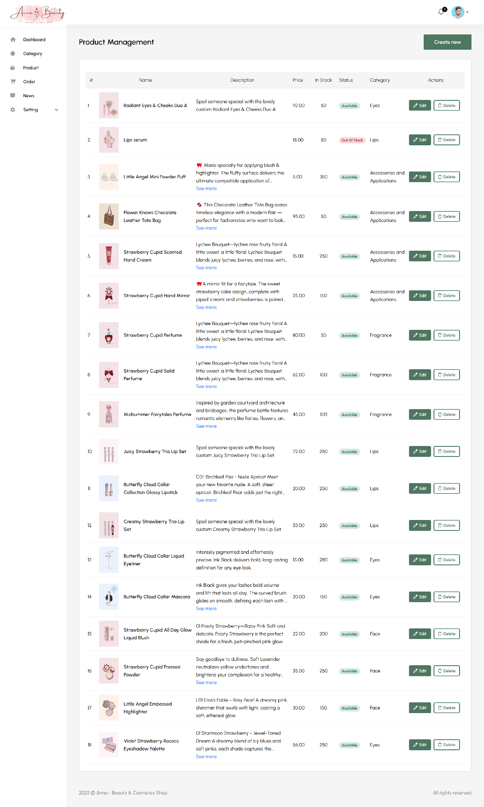

*Figure 27. Product Management page*

The admin CRUD (Create, Read, Update, Delete) system for managing products in the shop.

#### Create Product

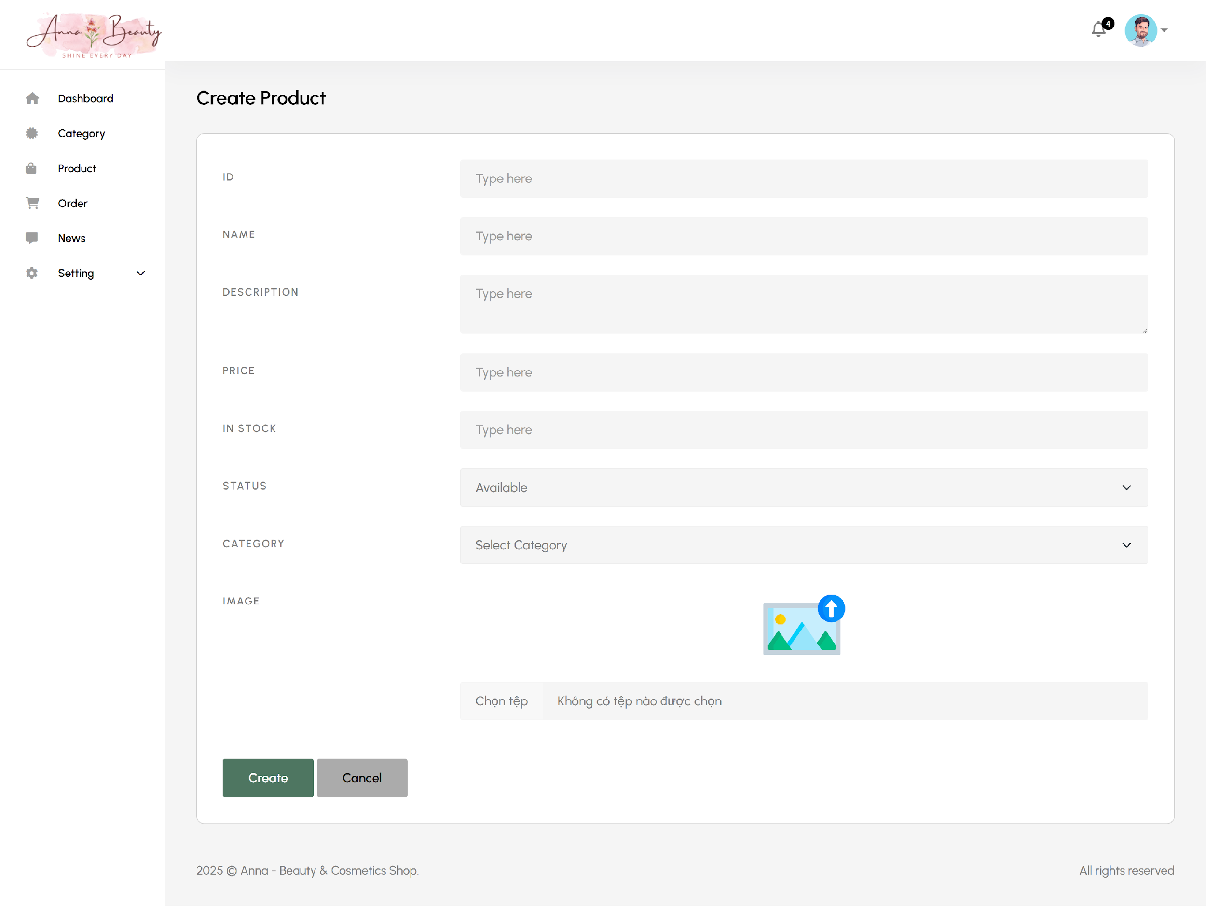

*Figure 28. Create product interface*

* **Description:** The “Create Product” interface allows admins to add new products to the system by entering relevant product details such as ID, name, description, price, stock quantity, status, category, and product image. Once all fields are filled, the admin can click "Create" to add the new product to the product list.
* **Implemented Features:**
* Admins can input all the necessary fields to create a new product, such as the product’s ID, name, description, price, stock, and category.
* An image uploader is provided to associate a product image with the new product.
* The status dropdown allows the admin to mark products as “Available” or “Out of Stock.”
* A “Create” button saves the product information in the system.
* **Evaluation:**
* The creation interface is intuitive and user-friendly, guiding the admin through each required field.
* The design of the interface ensures that admins can quickly create and add new products to the system.
* A future enhancement could include a more robust image upload system with automatic image resizing and optimization.

#### Read

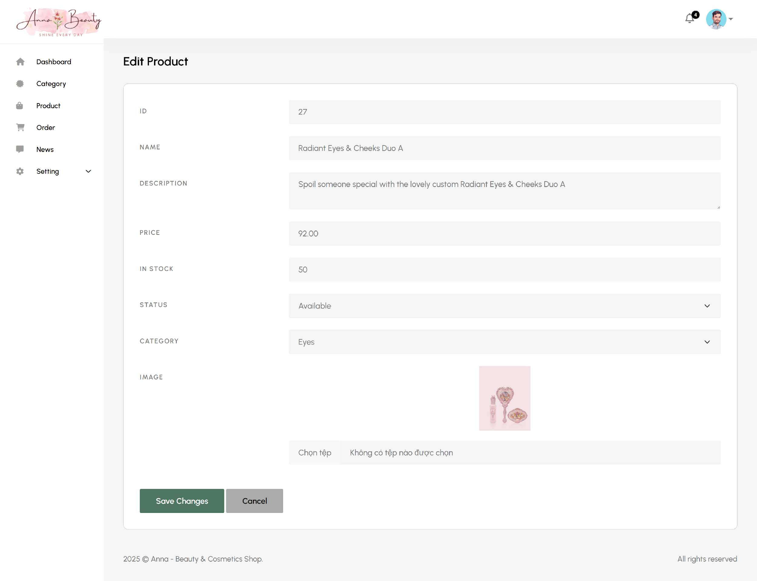

*Figure 29. Read category interface*

* **Description:** The “Read” interface allows admins to view a list of all products in the system, displaying product names, descriptions, prices, stock status, and other related details.
* **Implemented Features:**
* Displays a table of all existing products with their key information, including name, description, price, stock quantity, and status.
* Each product has an action column where the admin can choose to edit or delete a product.
* The products are listed with pagination for easier management if the database grows large.
* **Evaluation:**
* This interface provides a quick overview of all products, allowing for effective management.
* It would be beneficial to add filtering options for sorting products by category or status to enhance navigation

#### Update



*Figure 30. Update product interface*

* **Description:** The “Update” interface enables admins to modify the details of an existing product. Admins can change product names, prices, descriptions, stock quantities, and other information.
* **Implemented Features:**
* Admins can select a product to edit by clicking the "Edit" button in the action column.
* The admin can update all product fields, including price, description, stock quantity, and status.
* An image update option is also provided to replace or add new product images.
* **Evaluation:**
* The update functionality works well and allows for easy modification of product details.
* Adding version control or product change history would allow for better tracking of updates made to each product.

#### Delete

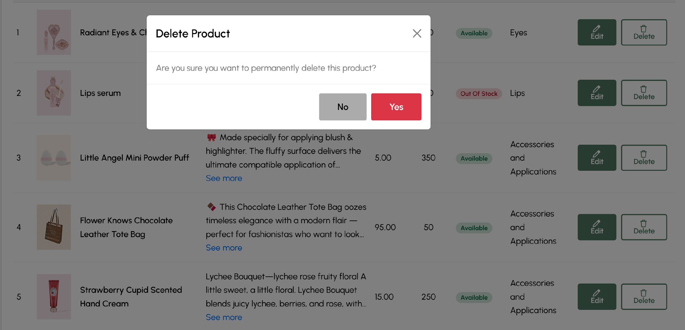

*Figure 31. Delete product interface*

* **Description:** The “Delete” interface allows admins to permanently remove a product from the system. When the delete button is clicked, a confirmation prompt ensures that the admin intends to delete the product.
* **Implemented Features:**
* Each product has a delete button in the action column, which opens a confirmation prompt.
* The confirmation prompt asks the admin to confirm their decision to delete the product, preventing accidental deletion.
* **Evaluation:**
* The delete feature is secure and prevents accidental product removal.
* It would be helpful to allow admins to restore deleted products within a certain timeframe, or provide an archive feature to retrieve deleted product data if needed.

#### Additional Features

* **Bulk Editing:** Admins can select multiple products and edit them at once (e.g., update prices, change stock quantity).
* **Category Association:** When creating or editing products, admins can associate them with one or more categories to enhance product organization.

#### Overall Evaluation

The Product page for the admin panel offers an efficient system for managing products within the Anna Cosmetics website. The interface allows for quick product creation, updating, and deletion, while providing essential features such as filtering, editing, and product status updates. Future updates could include enhanced bulk editing options, a more robust image management system, and additional features such as product analytics or automated stock alerts. These improvements would further streamline the admin process and contribute to a more effective product management experience.

### Order page for admin panel

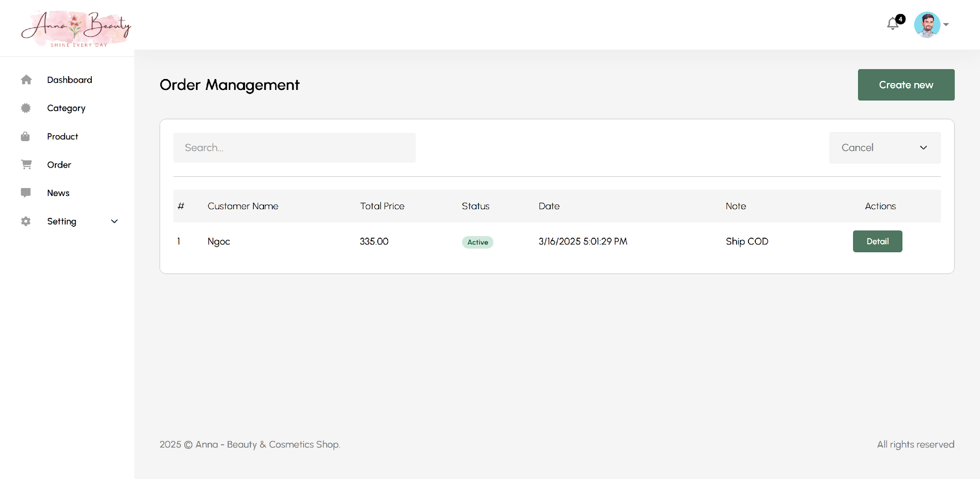

*Figure 32. Order Management page*

The Order page for admin panel allows admins to view and check the details of customer orders, including order status, total price, and shipping notes.

#### Create Order

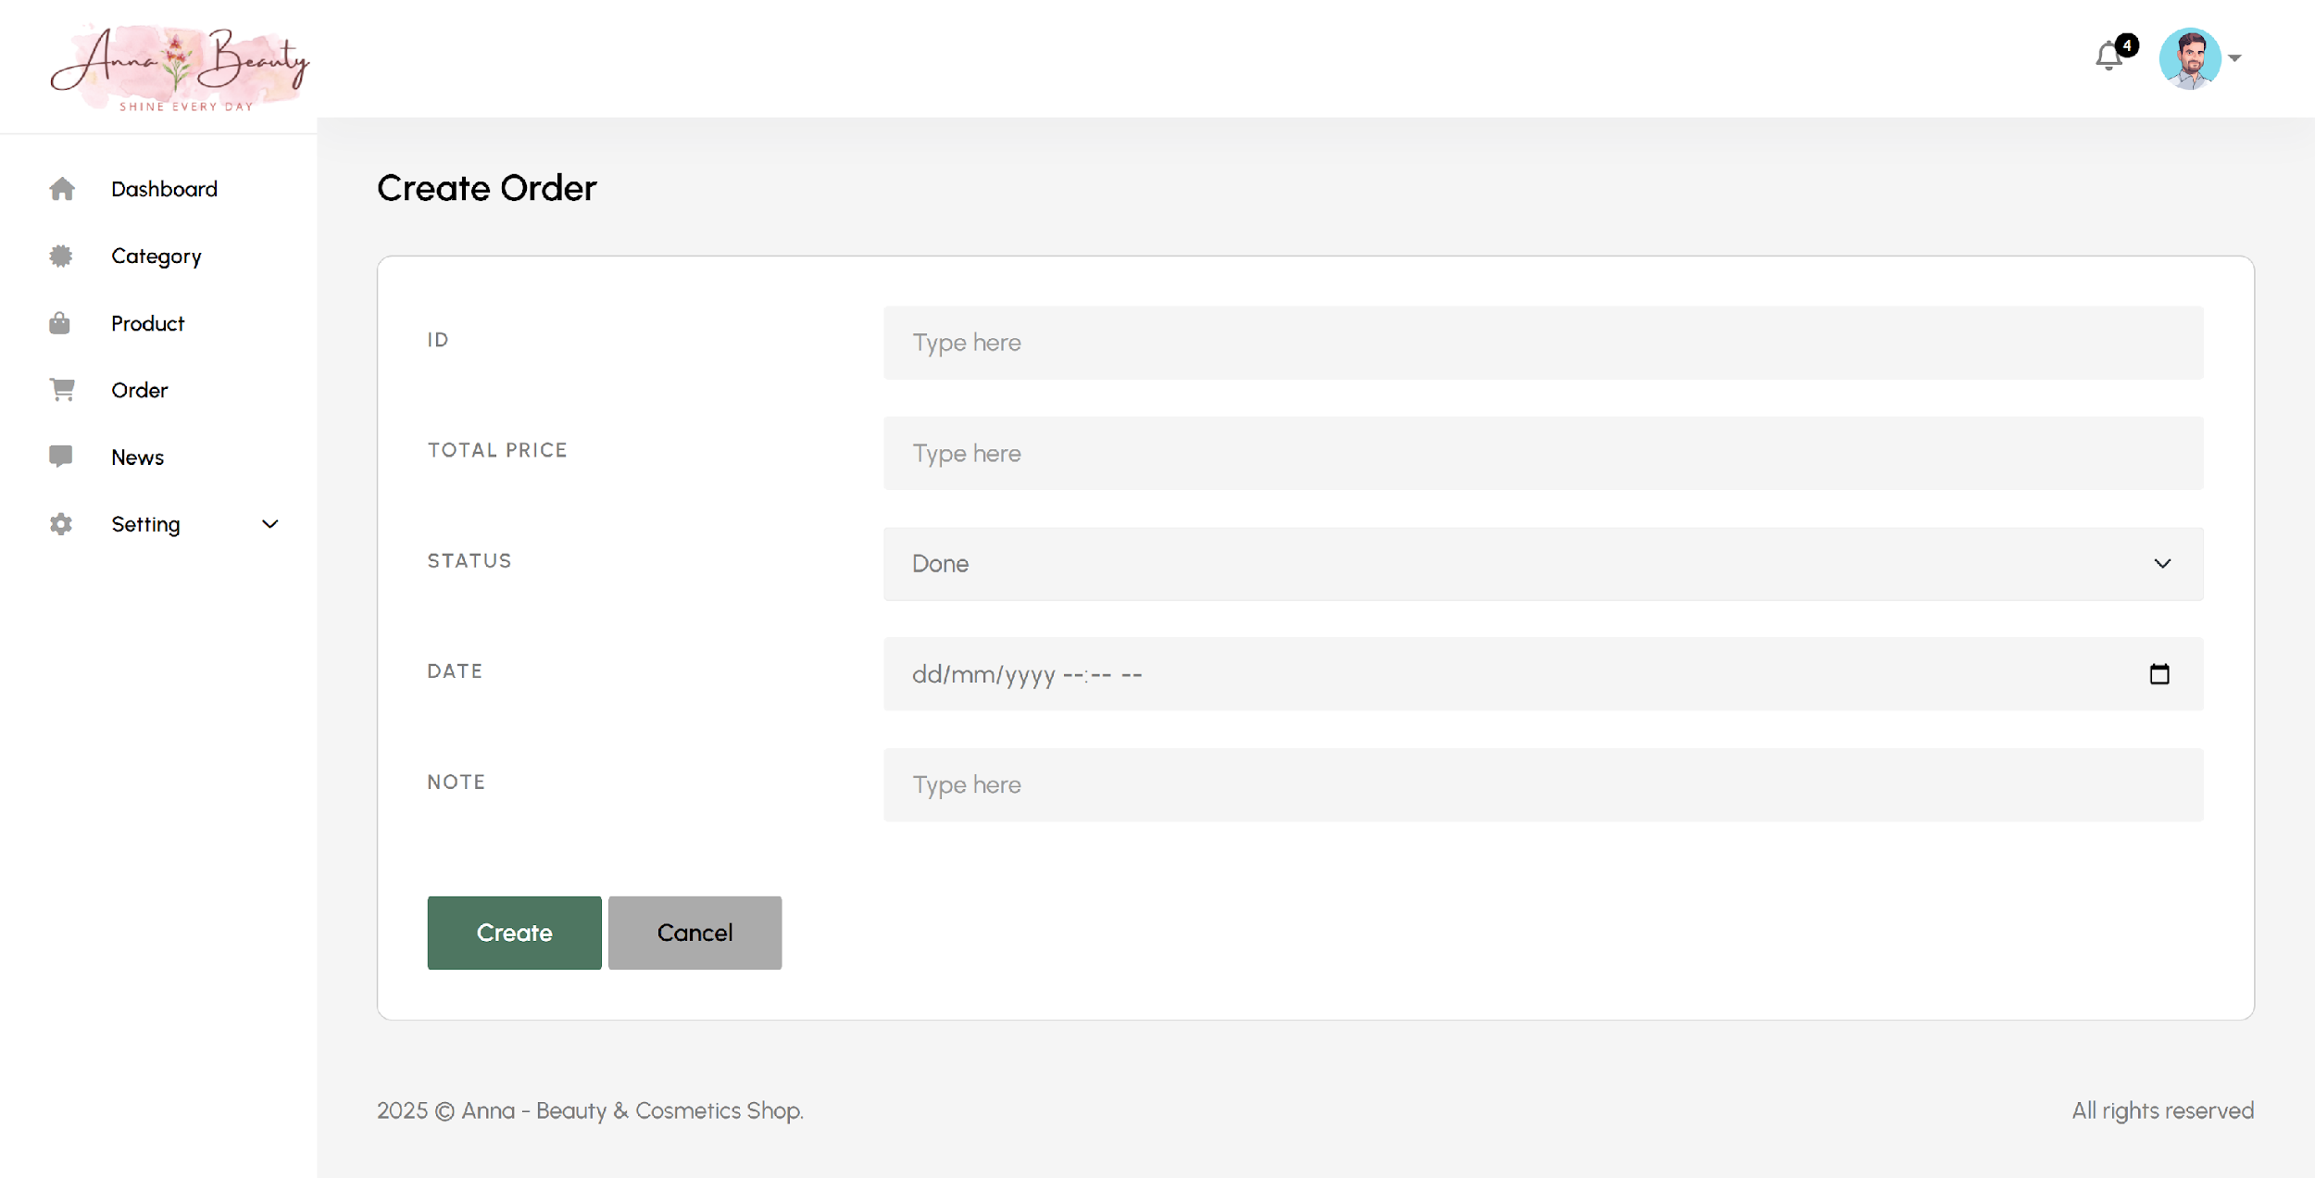

*Figure 33. Create order interface*

* **Description:** The “Create Order” interface allows admins to create new orders in the system. Admins can input essential order information such as order ID, total price, status, order date, and any additional notes. This page provides a form layout for easy input, including dropdown menus for selecting order status and date.
* **Implemented Features:**
* **ID input field**: Allows the admin to specify a unique ID for the new order.
* **Total Price input field**: Admin can enter the total price of the order.
* **Status dropdown**: Provides predefined status options for the order (e.g., “Done”).
* **Date picker**: Allows the admin to select the date the order was placed.
* **Note input field**: Admin can enter any additional notes related to the order.
* **Create and Cancel buttons**: The admin can either create the order by pressing “Create” or cancel the process with the “Cancel” button.
* **Evaluation:** The “Create Order” page is well-structured for easy data entry. The layout is user-friendly, offering essential input fields that make order creation a quick and straightforward process. The use of dropdowns and date pickers helps prevent errors in data entry, ensuring that all information is accurate and consistent. However, additional validations for input fields (e.g., for price and ID) could improve data integrity further.

#### Read

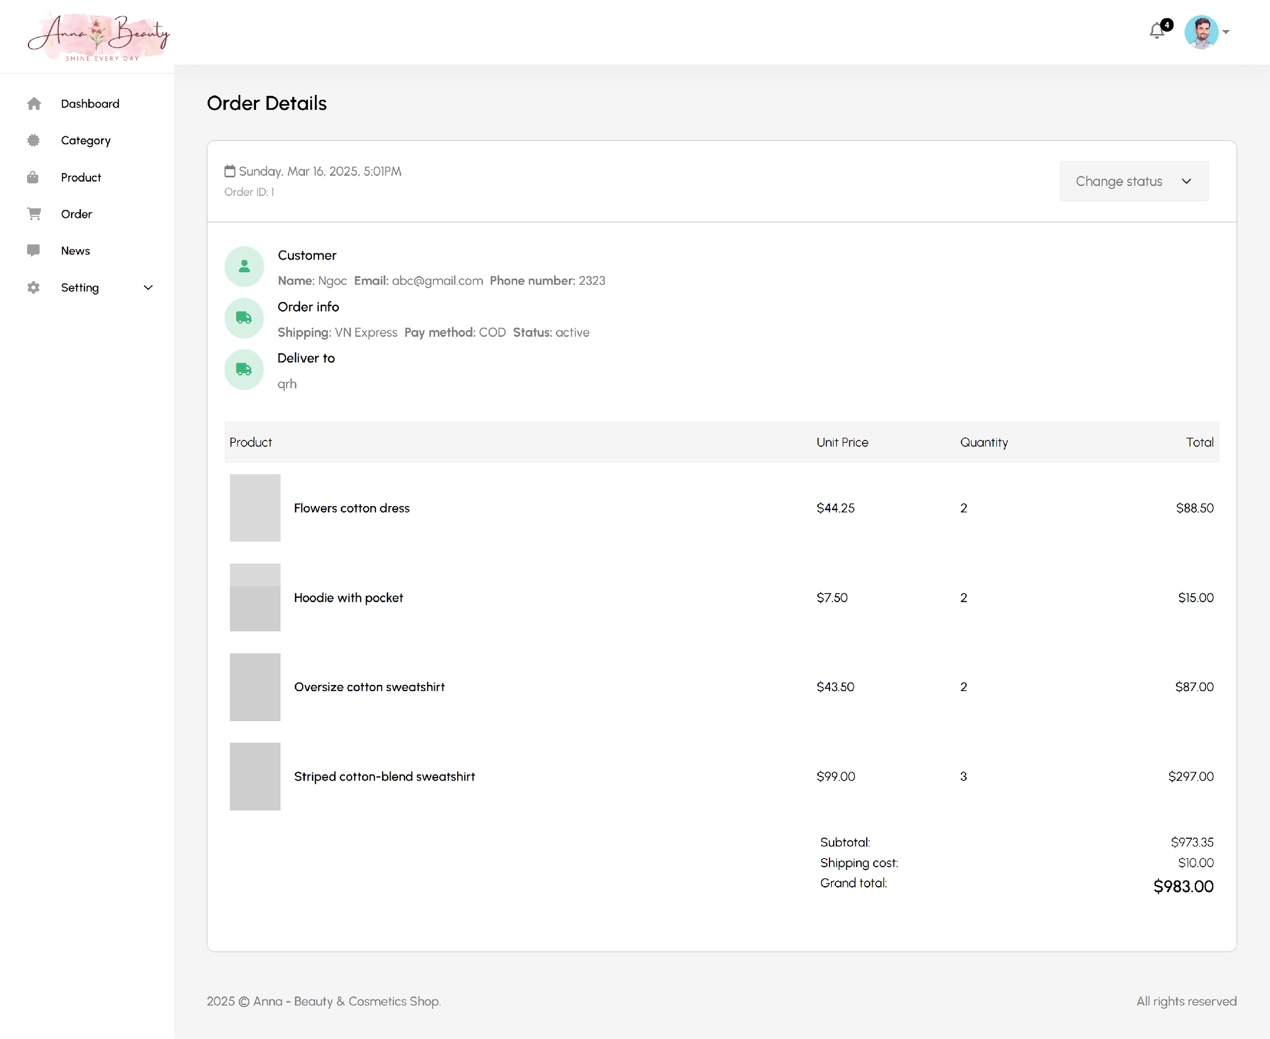

*Figure 34. Read Order interface*

* **Description:** The “Order Details” page allows admins to view the complete details of a specific order, including customer information, shipping details, and a breakdown of the products in the order. It shows the unit price, quantity, and total for each product, as well as the subtotal and grand total for the order. This page also provides the ability to change the order status.
* **Implemented Features:**
* **Customer Information**: Displays the customer’s name, email, phone number, and delivery address.
* **Order Information**: Shows the shipping method, payment method (COD), and the current status of the order (active).
* **Product List**: Lists all products in the order with columns for the product name, unit price, quantity, and total cost for each item.
* **Total Calculation**: Shows the subtotal (the total cost of products), the shipping cost, and the grand total for the order.
* **Status Change Option**: Admins can change the order’s status through a dropdown menu (e.g., mark it as shipped or completed).
* **Order ID and Timestamp**: Displays the order ID and the date/time when the order was placed.
* **Evaluation:** The “Order Details” page is a comprehensive view of an order’s information, providing all necessary details in a clean and organized manner. The inclusion of product-specific data (unit price, quantity, and total cost) is very useful for order review. The status change feature is a helpful tool for admin to update the order status as it progresses. However, the page could benefit from additional functionality, such as the ability to edit or delete products within the order. The overall design is intuitive and user-friendly, allowing quick access to all essential details.

#### Additional Features

#### Search Function: Helps admins quickly locate specific orders.

#### Order Status Update: Admins can update order status directly from the order details page.

#### Product Breakdown: Displays product details like unit price, quantity, and total for better transparency.

#### Grand Total Calculation: Automatically calculates subtotal, shipping costs, and grand total.

#### Responsive Layout: Ensures a smooth experience on all devices.

#### Overall Evaluation

The order management system provides an easy-to-use interface with features like search, detailed order information, and status updates, making it efficient for admins. While it meets basic needs, future enhancements, such as product editing and customer communication, could further improve the system. Overall, it is a solid foundation for managing orders effectively.

# CONCLUSION AND FUTURE WORKS

This chapter provides a summary of the knowledge, skills, and outcomes gained during the development of this project. It highlights the key achievements and explains the future improvements that will be integrated in the next phase to fully realize the potential of the system. This phase will address certain gaps, focusing on enhancing user experience and incorporating more advanced features.

## Conclusion

Through the successful completion of this project, I have acquired significant knowledge, practical experience, and essential skills that are highly applicable to real-world software development. The process has enabled me to develop a deeper understanding of both frontend and backend technologies and their integration, as well as the use of modern tools for building functional and user-friendly web applications.

### Knowledge Gained

This project significantly expanded my understanding of web development, particularly in the areas of backend operations and database management. The use of frameworks such as ASP.NET for backend development and MySQL for managing relational databases has been invaluable. It has deepened my knowledge of building secure, scalable, and data-driven systems.

In frontend development, I gained proficiency in using HTML/CSS for layout design and JavaScript to make the site interactive and responsive. The project also provided me with the opportunity to explore and implement version control systems like Git, which helped track changes, collaborate on the codebase, and keep the project organized and efficient.

### Product Outcomes

Through this project, we successfully developed a functional and practical web application for Anna Cosmetics, achieving the following outcomes:

**Home page for customer**

* The home page provides a seamless shopping experience, allowing customers to log in, browse products, and add items to their shopping cart. This feature simplifies the shopping process and enhances user convenience, improving the overall customer experience.

**Login Page**

* The login page allows customers to securely access their accounts, providing them with personalized shopping features and order management options. It ensures that users can log in and out with ease.

**Register Page**

* The registration page enables new customers to create an account, making it easy for them to manage their profile and view their order history.

**Shop Page**

* The shop page displays all available products, with options to sort by name, category, and price. It also includes a search bar for finding products quickly. This page allows customers to view, filter, and browse products effortlessly.

**Product Detail Page**

* The product detail page provides comprehensive information about each product, including images, descriptions, and price. It allows customers to make informed purchasing decisions by offering clear and detailed product data.

**Compare Page**

* The compare page allows customers to compare multiple products side by side. This feature helps users make the best choice by displaying key product information such as price, stock status, and discounts.

**About Us Page**

* The “About Us” page provides visitors with insight into the brand’s vision, values, and the vibrant community that surrounds Anna Cosmetics. It enhances the company’s story and builds customer trust.

**CRUD features for admin**

* Category Management: The admin panel allows administrators to manage product categories by adding, updating, and deleting categories. This ensures that the products are organized properly for better user navigation and browsing.
* Product Management: The admin can manage products through the CRUD interface, including adding new products, updating product details, viewing existing products, and deleting products that are no longer needed. This ensures smooth inventory management.
* Order Management: The admin panel includes functionality for managing customer orders, allowing administrators to view, update, and track orders. This ensures that all customer orders are processed and handled efficiently.

### Skills Developed

Throughout this project, I enhanced both technical and soft skills essential for the successful development of a modern e-commerce website. Below are the key skills developed:

* Database Management: I improved my skills in creating and managing databases, writing complex queries, and designing database schemas for efficient data storage and retrieval. This knowledge is fundamental for building scalable web applications.
* Problem-Solving and Debugging: I strengthened my problem-solving abilities, particularly in troubleshooting both frontend and backend issues, ensuring that the application works seamlessly across different browsers and platforms.
* Project Management and Version Control: Using Git to organize, manage, and collaborate on the codebase taught me valuable skills in version control, tracking changes, and coordinating with team members for efficient project completion.
* Teamwork and Communication: Working with a team, I learned how to effectively communicate ideas, divide tasks, and resolve conflicts. These soft skills have been instrumental in the success of the project, as collaboration was key to its timely completion.
* Time Management: Managing the project tasks and deadlines allowed me to develop strong time management skills, ensuring that each stage of the project was completed efficiently and within the given time frame.

### Team Growth

This project also provided an opportunity to strengthen our teamwork and collaboration skills. It was a shared effort that required constant communication and coordination among team members. The following areas of team development were key to the project’s success:

* Improved Communication: The project taught me the importance of clear, open communication. Listening to others’ ideas, expressing my own thoughts, and being receptive to feedback ensured that the team worked smoothly and efficiently.
* Collaboration and Task Division: We worked together to divide tasks based on individual strengths. This made the project more manageable and allowed us to focus on delivering the best results in each area.
* Time Management and Deadline Adherence: Working on different aspects of the project, we learned how to prioritize tasks, manage our time effectively, and meet deadlines. This was crucial to keep the project moving forward without delays.

## Future works

While this project has met its core objectives, there are several opportunities for further development in the next phase. Future improvements will focus on creating a seamless, robust platform that enhances the customer experience and optimizes backend functionality. Some of the planned features for future development include:

* Integration of Multiple Payment Methods: Currently, the system relies on Cash on Delivery (COD). The future work will involve integrating additional payment methods, such as credit/debit card payments, online payment gateways like PayPal or Stripe, and mobile wallet solutions, to cater to a wider range of customer preferences. This will improve the flexibility and convenience of the payment process.
* AI Integration for Customer Support (Q&A): Implementing AI-powered Q&A functionality will allow the system to automatically address frequently asked questions (FAQs) and assist customers in real-time. This feature will improve customer satisfaction by providing immediate answers and enhancing the overall support experience.
* Shopping Cart Functionality: The current version of the platform lacks full shopping cart capabilities (such as adding, updating, and deleting products). In the next phase, the shopping cart system will be fully implemented to allow customers to manage their items before checkout. This will include a seamless interface for users to modify product quantities, remove items, and review their selections before completing their purchase.
* Improvement in User Interaction: Further enhancements to the user interface will create a more engaging and intuitive experience for customers. Adding features like “quick view” for products, personalized recommendations based on browsing history, and integrating customer reviews will increase customer engagement, satisfaction, and drive conversions.
* Admin Panel Enhancements: The admin panel will be expanded to include better reporting features, such as detailed analytics on customer behavior, sales trends, and inventory management. These insights will enable administrators to make data-driven decisions, streamline inventory management, and optimize the overall operation of the platform.

In conclusion, these future enhancements will not only complete the current system but also ensure that it remains scalable, secure, and user-friendly. By addressing these areas in the next phase, the platform will be fully equipped to offer a seamless, interactive, and efficient experience for both customers and administrators. These improvements will ensure the system is ready for real-world application, providing a complete e-commerce solution that meets the evolving expectations of both businesses and customers.

REFERENCES

1. D. R. Brooks, An Introduction to HTML and JavaScript: for Scientists and Engineers, 2007
2. Meyer, Eric A., Cascading Style Sheets: The Definitive Guide, Third Edition, 2006
3. D. Flanagan and P. Ferguson, JavaScript: The Definitive Guide, 1998
4. Andrew Lock, ASP.NET Core in Action, Third Edition, 2023
5. Vinicius Grippa and Sergey Kuzmichev, O’Reilly Media, Learning MySQL: Get a Handle on Your Data, 2021
6. Michell Queiroz, Yasin N. Silva, Isadora Almeida, SQL: From Traditional Databases to Big Data, 2016
7. Sarah Guthals, Phil Haack, *GitHub For Dummies 1st Edition,* 2019
8. Ashima Mehta, Aditi Paul, Responsive Web Design and Its Impact on User Experience, 2023
9. Waseem I., Abdelaziz I. Hammouri, Responsive Web Design Techniques, 2016